

E-Project

**Web Designing**

**Pharmacy**

|  |  |
| --- | --- |
| **Authors** | **Aptech – C2003L** |
| 1. GIANG TAN PHUC - Student1267711 2. VO KHANH LOC - Student1191096 3. DANG VAN TUE - Student1252342 4. TRAN PHUC TUYEN - Student1241205 |
| **Centre Name** | Aprotrain Aptech |
| **Date** | 9th,April 2022 |
| **Semester** | Semester III |
| **Instructor** | MR. PHAN HUU TRI |

**HCM City, 9th April 2022**

Table of Contents

CHAPTER I: OVERVIEW 3

CHAPTER II: REQUIREMENTS 4

Project Designing: 5

CHAPTER III: E-PROJECT DESIGN 7

1. DFD Design for eProject 7

➢ Define DFD 7

➢ Main Components of DFD 7

➢ DFD Analysis: Design main functions of system 8

2. Database Structure Design for eProject 8

CHAPTER IV: INTERFACE SNAPSHOT 8

CHAPTER V: USER GUIDE 11

1. Homepage 11

2. Register New Account 14

3. Login: 16

4. Logout: 16

5. Features: 17

6. Feedback: 19

7. Career: 20

CHAPTER VI: ADMIN GUIDE 22

1. Get to Administrator View 22

2. Dashboard 23

3. Get to Manage Account 23

4. Get to Candidate 26

5. Get to Client 29

6. Get to Product manage 30

7. Get to Job manage 33

8. Get to Feedback management 36

9. Get to Invoice management 38

10. Get to Job Application management 39

11. Get to Category management 40

12. Get to Role management 42

13. Get to Job Application Status management 45

CHAPTER VII: DEVELOPER GUIDE 47

1. Visual Studio 2022 – ASP.NET 47

a. Change Port: 47

2.Microsoft SQL Server Management Studio 18: 48

3.Visual Code - Angular: 49

Access the website 50

# CHAPTER I: OVERVIEW

1. **Introduce the topic:**

The pharmaceuticals sector is a highly R&D intensive industry. The XYZ is an Pharmaceutials company which deals with products like Capsule/Encapsulation, Tablet, Liquid Filling, Blending, Process Equipment, Used Equipment. This organization now wants the entire process to be explained in as a web application so as to enhance the advertisement of the company and to increase its profit and also proviced the list of the functionalities expected.

1. **Sitemap:**

The website include two parts: Customer Site and Adminitrator Site:

-Sitemap for Customer Site:

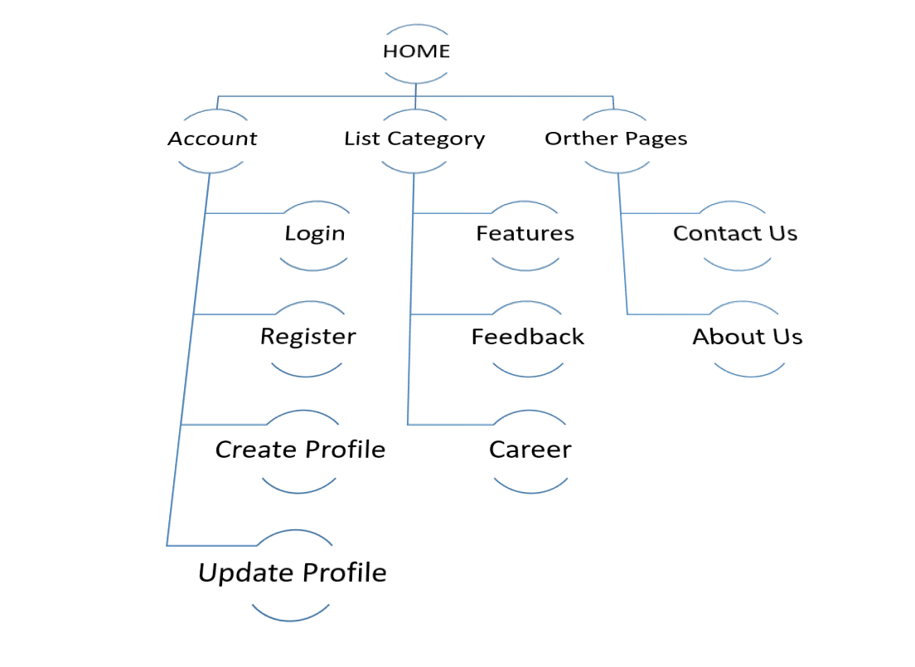

-Sitemap for Adminitrator :

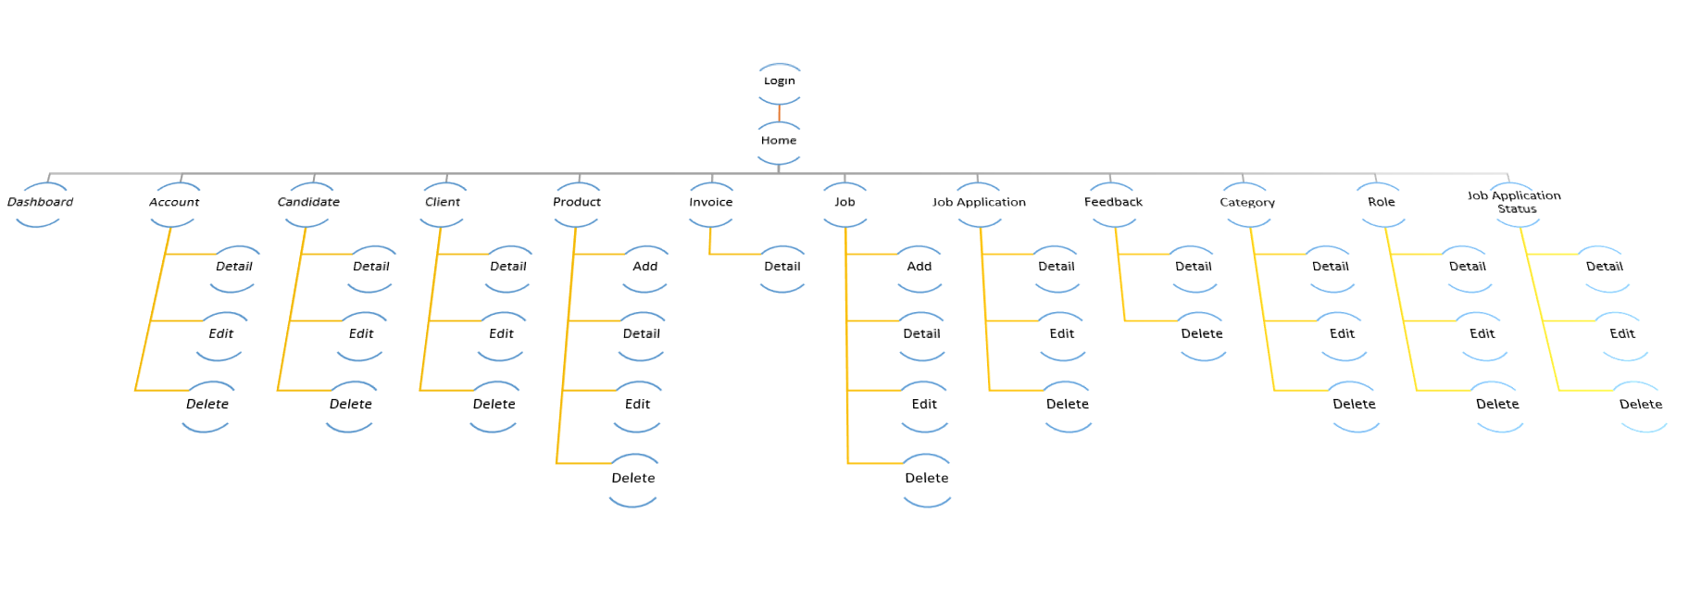

1. **Perpose of website:**

The goal of website is to increase sales for company.

Recruit more employees and Introduce about company.

1. **Some main pages:**

-Home page: This is an introduction page , show-off the hottest product.

- Features : show-off all of products.

-Feedback : The site help client connect with company throught feedback.

-Career : Help Company recruit employees well throught their profile.

CHAPTER II: REQUIREMENTS

**Problem Statement**

The Company has approached you to make the website and also provided the list of all the links and functionalities provided. They also want to provide a link of making a career where the interested candidates can login and provide their information (like their personal and education, professional details and also they will have the link to upload their resume)

There would be link for User Quote where user can provide their valuable feedback or any requirement.

It also wants to explain the list of the process being carried along with the details and dimension. The Process like Capsule/Encapsulation, Tablet and Liquid Filling must be explained.

# Project Designing:

The Page should have the following links and menus

* ***Home Page:*** It should have the introduction description about the company. All the links must be stated in this page. The link like Home, About us, Products, Contact us, Careers, Quote, Admin Login.
* ***About us:*** it should flash the details of the Company (organization)
* ***Products:*** Here the list of the Products which are developed must be stated. Products like:
  + **Capsule/ Encapsulation**: The details of the products must be entered like
    - * Output
      * Capsule size ( in mm)
      * Machine dimension
      * shipping weight ( in kg)

Examples of the list of the products are mentioned below:

* + - * Profill 100 (2000 c/hr): it produces 2000 capsule per hour.
      * Profill 3007 (9000 c/hr): it produces 9000 capsules per hour.
      * Model 8S (18000 c/hr): it produces 18000 capsules per hour. Note you can take any other products also.
  + **Tablet:** Here the details of the Tablet process must be there. It will store the details like
    - * Model number
      * Dies ( like 1 set, 2 set and so on)
      * Max Pressure
      * Max Diameter of tablet (in mm)
      * Max depth of fill (in mm)
      * Production capacity
      * Machine size
      * Net Weight (in kg)

Examples of the tablet are mentioned below

* + - * TDP
      * VSP
      * CP 501 (Note you can take any other product also)
  + **Liquid Filling:** Here the details of the Liquid filling must be explained. It will store the details like :
    - * Air pressure
      * Air Volume
      * Filling Speed ( Bottles/min)
      * Filling Range ( in ml)
    - Examples of the Liquid filling is DHF( Double Headed Filter)
* ***Contact Us*:** Here the contact details must be flashed.
* ***Quote us:*** Here the suggestion or effective feedback can be provided. The details like :
  + Full Name
  + Company Name
  + Address
  + City
  + State
  + Postal Code
  + Country
  + Email Address
  + Phone
  + Comments
* ***Career:*** It will provide the candidate opportunity to apply for the job by creating their account. There will be two section one for Candidate Login and other creating the account.
  + Candidate Login : It will open the particular candidate account by using authentication( with their existing email Id and password they select). Once the account is opened the candidate will get three tabs to be modify:
    - * Resume (for uploading the resume)
      * Personal details
      * Education details
  + Creating Account: Here the candidate account will be created by filling all the above mentioned details along with the password (authentication purpose).
* ***Admin login:*** it will have to main task
  + The details of the site can be updated. Admin can also view the details of the job seeker candidate.
  + If the candidate profile is found to be interest then their will be option of Email in the same page. Once the admin click on the email option then a composing mail window must be opened with option like TO, Subject, Text and Send button. In the text the admin will call the selected candidate for the interview.

# CHAPTER III: E-PROJECT DESIGN

1. ***DFD Design for eProject***

* **Define DFD**
* Data Flows Diagram (DFD) describes the information flow in the system. The next step of system analysis is to consider in detail the information necessary for the implementation for functions discussed above and the one necessary for the improvement of the functions. Modeling tool frequently used for this purpose is DFD. DFD will support 4 main activities.
  + **Analysis:** DFD is used to determine requirement of users. From DFD, all system stakeholders can share the same view on how the data will flow within the system and between the functions.
  + **Designing:** DFD is used to map out plan and illustrate solution to system analysts and other stakeholders while designing a new system.
  + **Communication:** DFD provides simplicity and ease-to-understand to system analysts as well as other stakeholders.
  + **Document**: DFD is used to provide special description of requirement and system design. DFD provide an overview of key functional components of the system, along with other tools like database dictionary, process specification, relevant stakeholders will get the idea of which information will be exchanged and how.
* 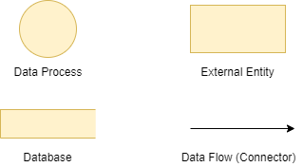**Main Components of DFD**
* **DFD Analysis: Design main functions of system**

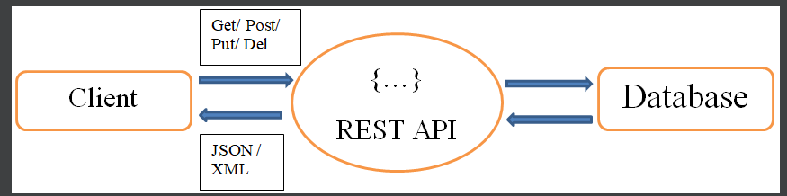

1. ***Database Structure Design for eProject***

**Link** : https://app.diagrams.net/#G1Xhn4AnLg9mGx13q6t6IkKkuVGSITIOqh

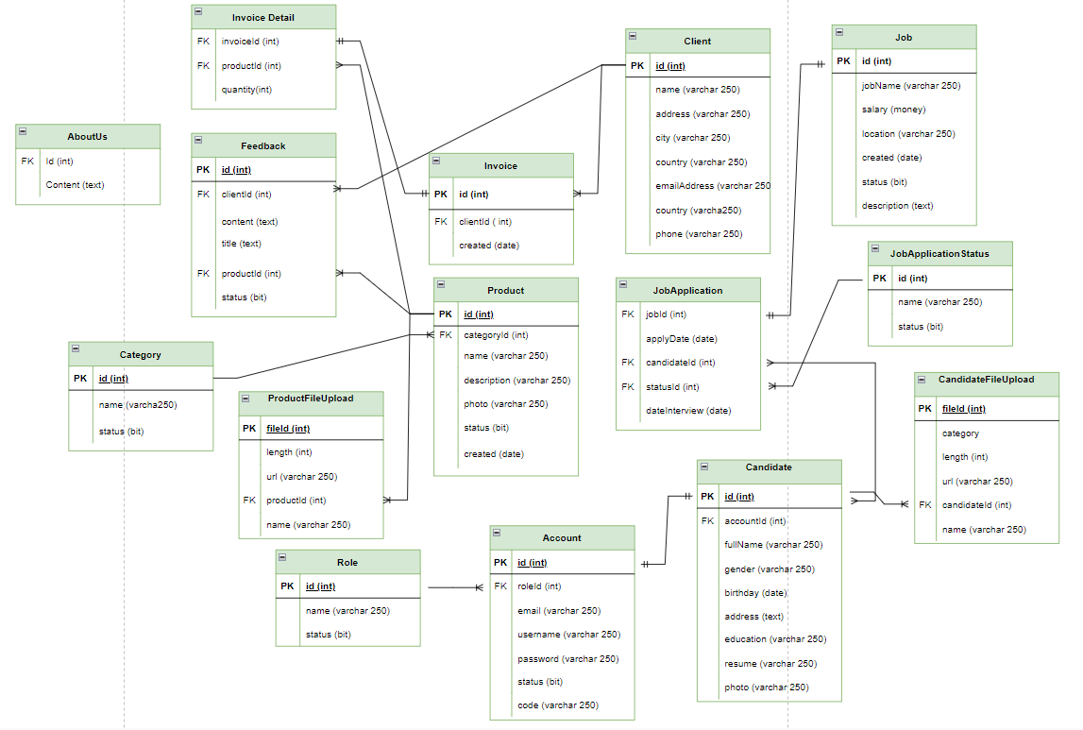

CHAPTER IV: INTERFACE SNAPSHOT

* **HOME PAGE:**

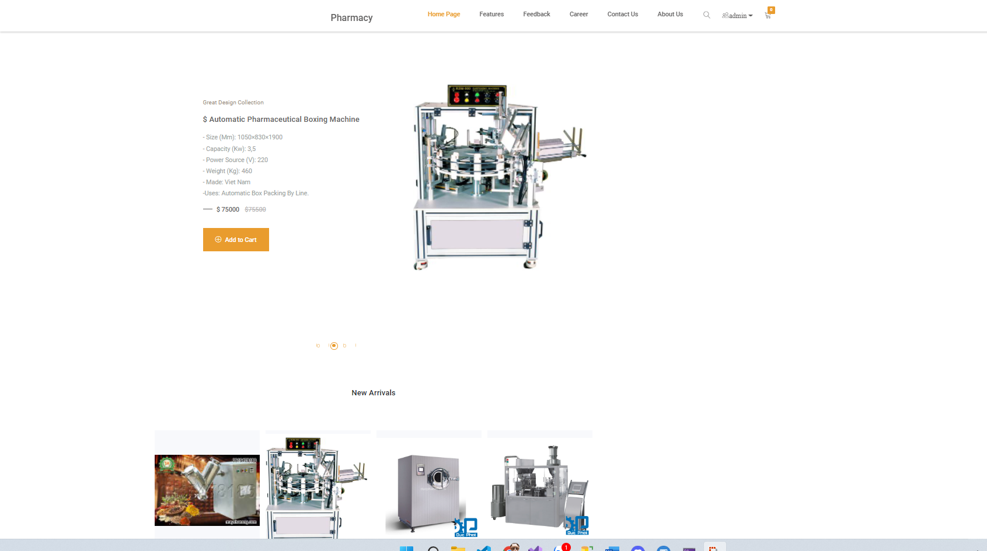

* **Register :**

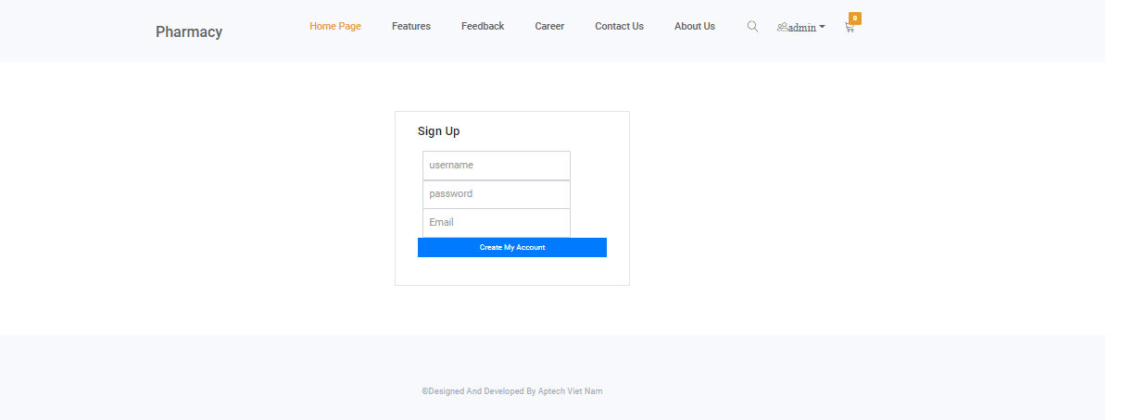

* **Login :**

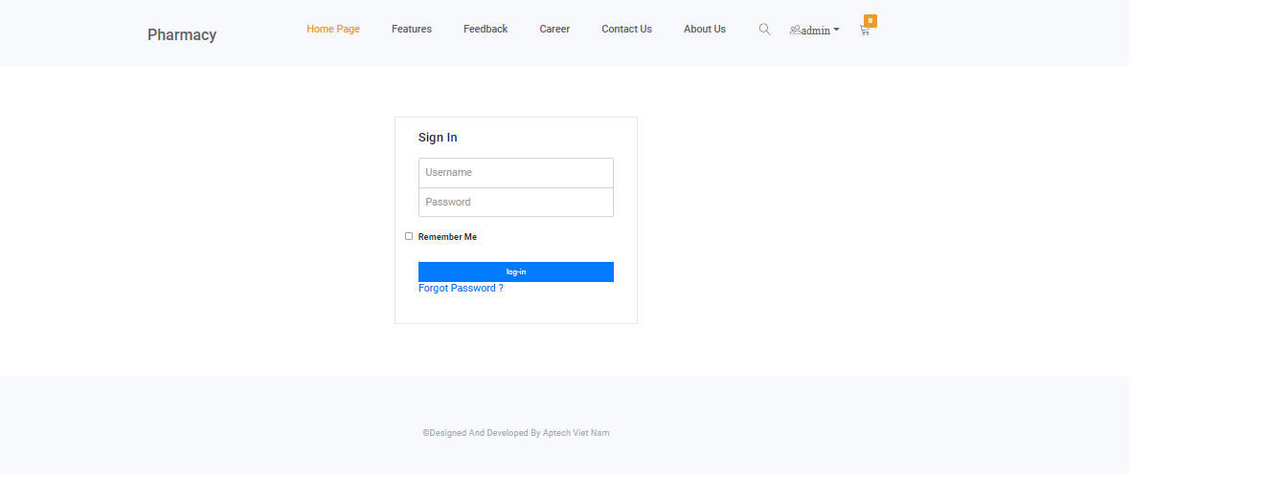

* **Feedback:**

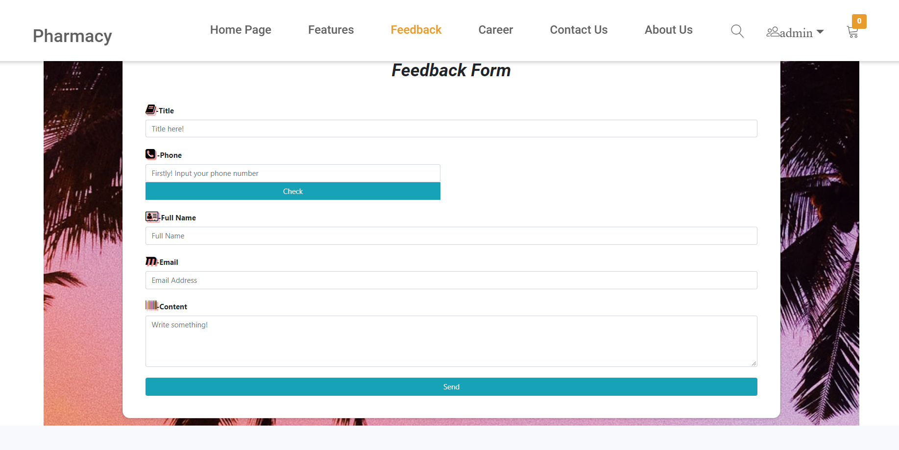

* **Career :**

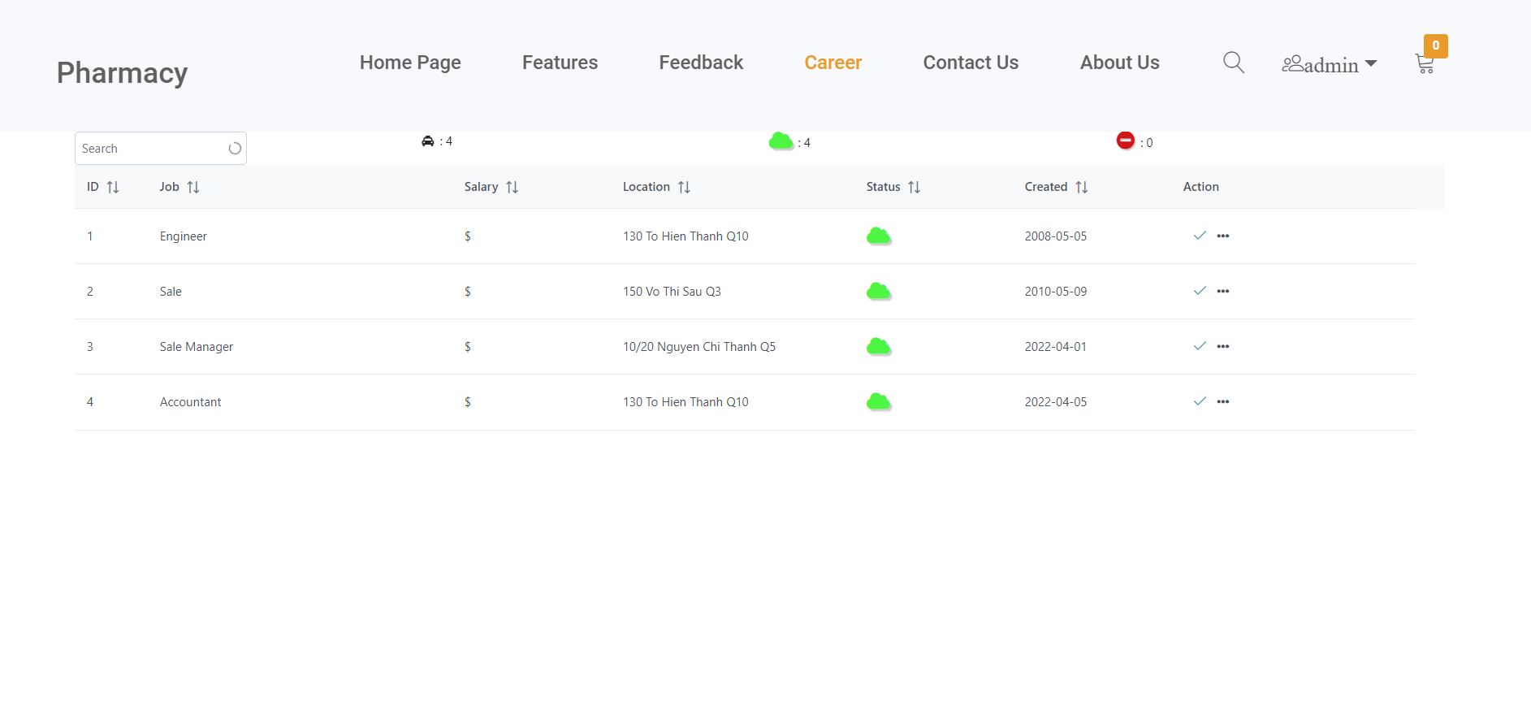

* **Contact Us :**

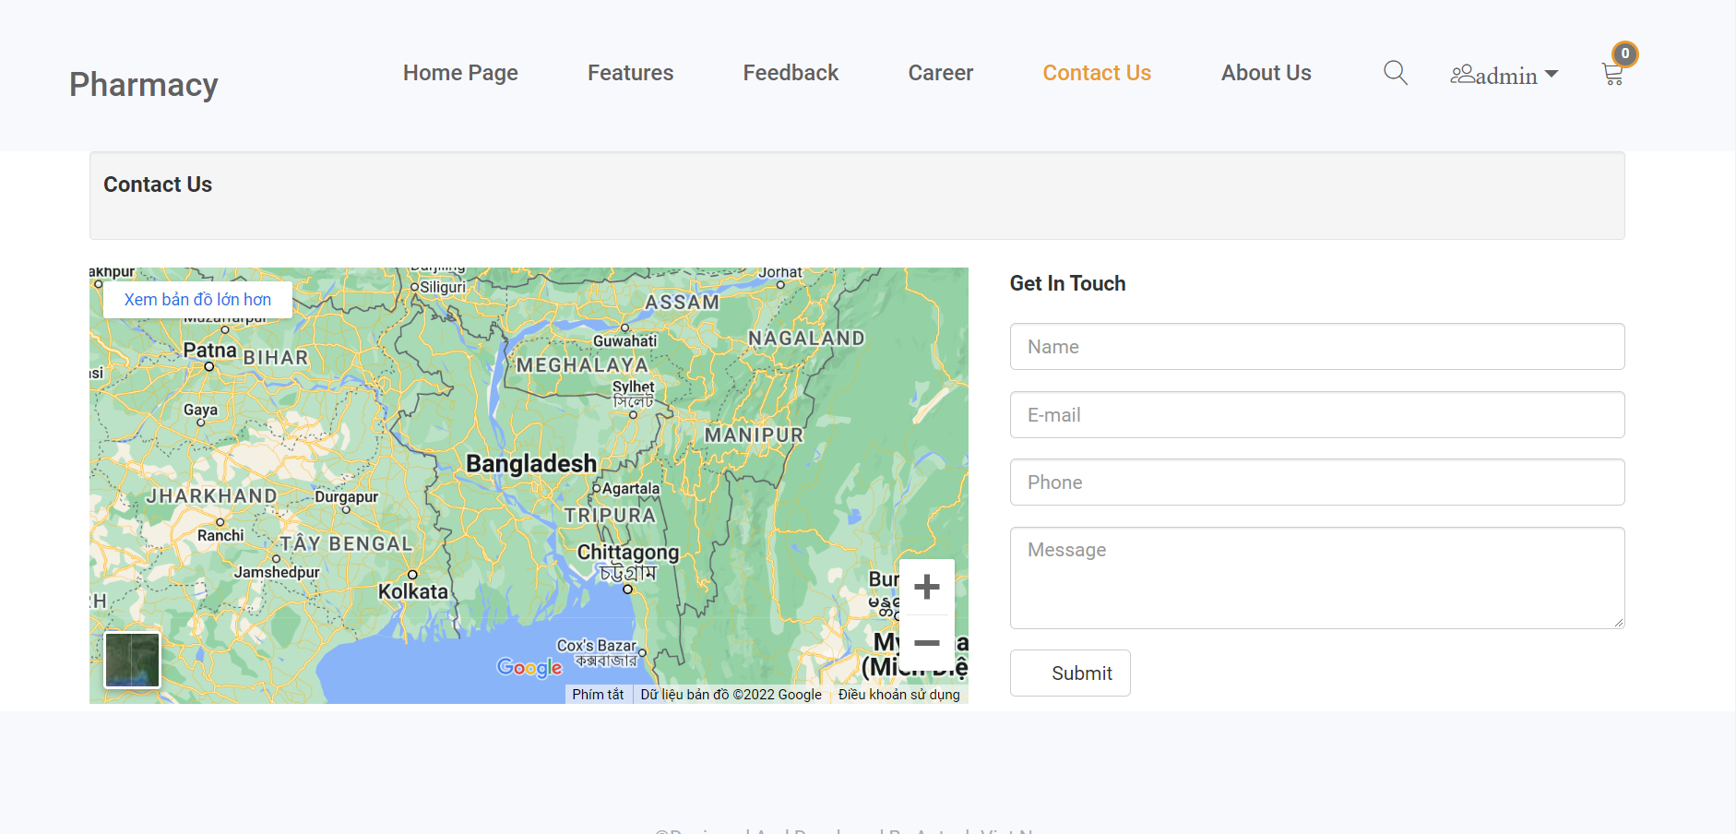

* **About Us :**

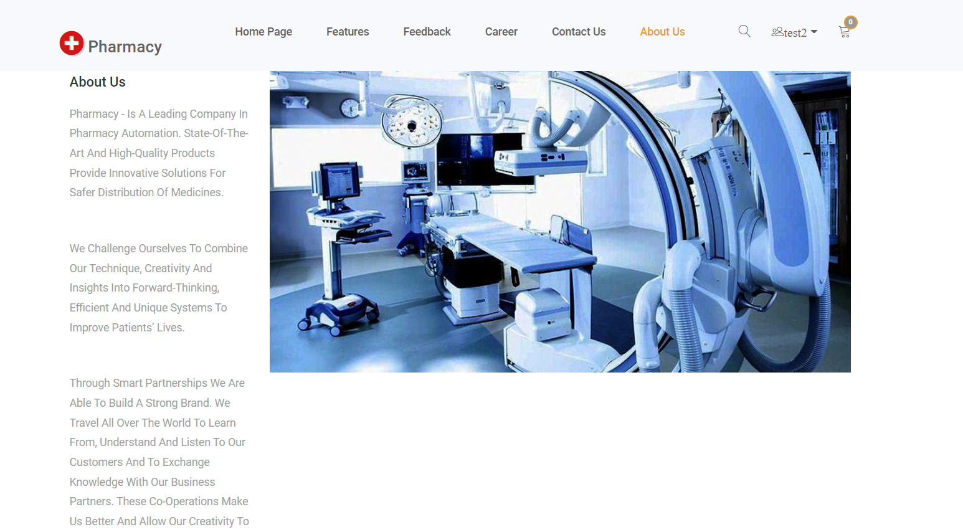

CHAPTER V: USER GUIDE

1. ***Homepage***

**Description:**

* The Homepage of the website will be the default page that end users will see when they get to use the website. The Homepage includes the following information/sections:
  + Three Hostest Products.
  + The collection of new Arrival Products

**Design and Operation:**

1. **The Homepage:**



* **How to get to other functions:**
* **Buy now:** Customers can go to this function to asscess to client page to buy product

|  |  |
| --- | --- |
| **Operation No.** | **Description** |
| 1 | *Click on Buy now Button to Access Client Page* |

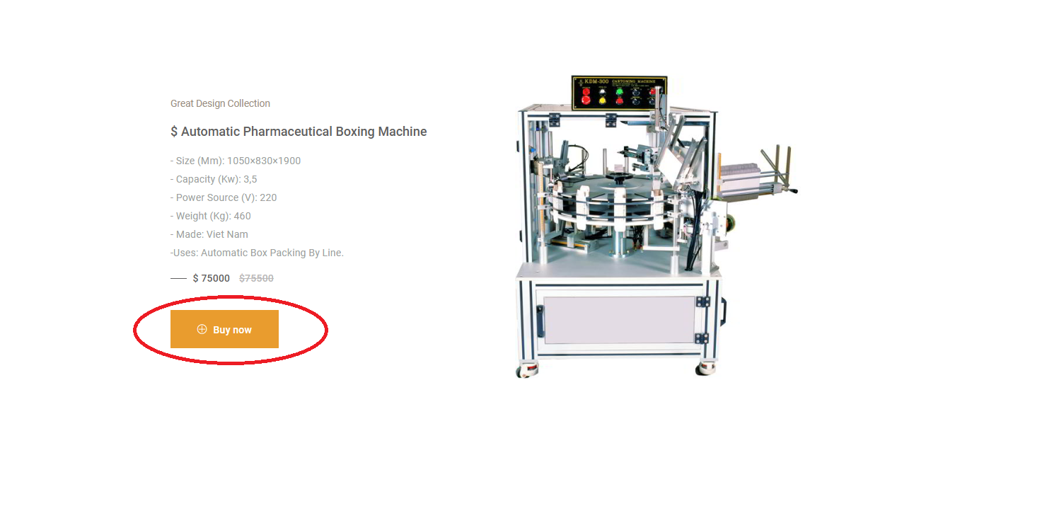

* **View “About Us”:** Customers can read about Company .

|  |  |
| --- | --- |
| **Operation No.** | **Description** |
| 1 | Click on this item on the header menu will direct customers to the page displaying About content |

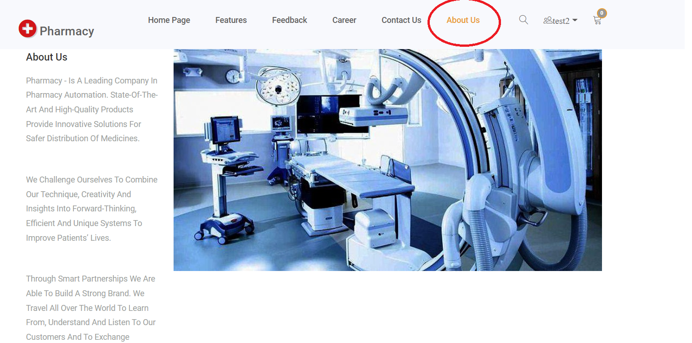

* **View “Contact Us”:** Customers can view location of Company.

|  |  |
| --- | --- |
| **Operation No.** | **Description** |
| 1 | Click on this item on the header menu will direct to the page displaying Contact Us’s content |

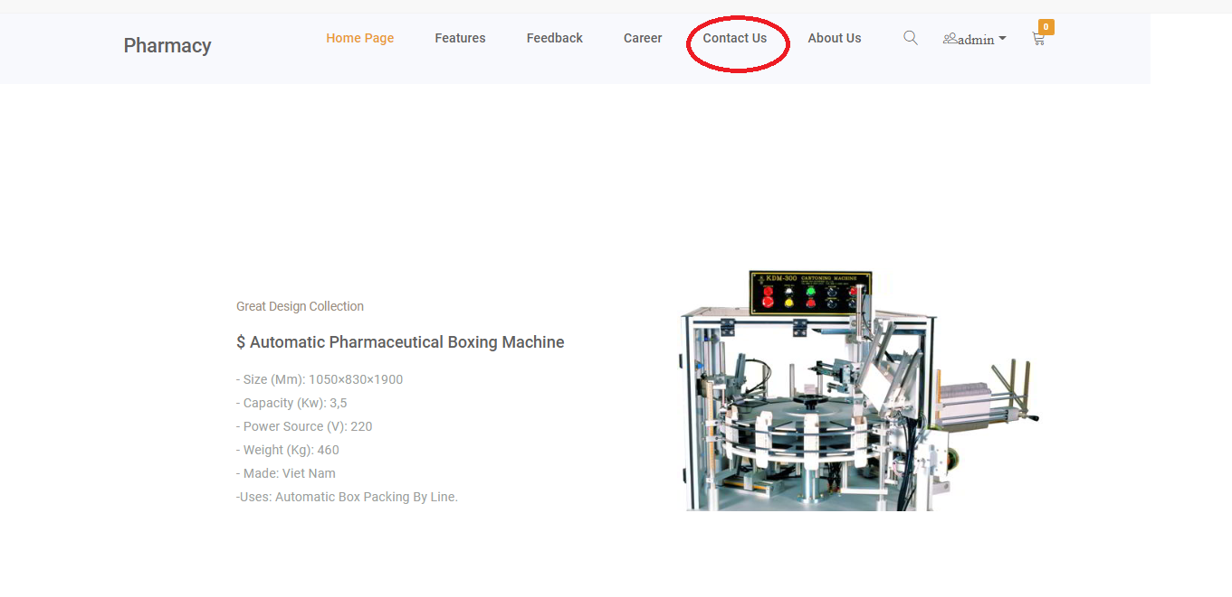

**Get back to homepage:** Customers can get back to the homepage buy click on Pharmacy logo in the left.

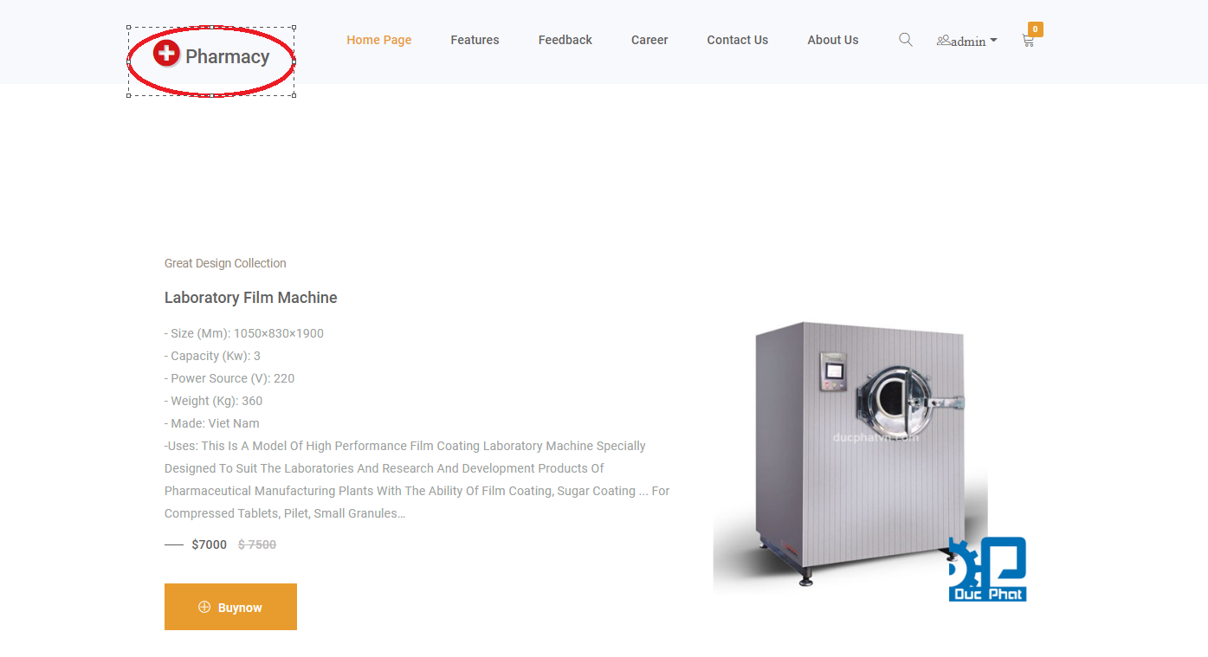

|  |  |
| --- | --- |
| * **Operation No.** | **Description** |
| 1 | Click on this item on the header menu will direct customers to the Homepage |

1. ***Register New Account***
   * + - 1. **Description:**

* Users can register for their new account so that they can do more action on the website which guest-users cannot do, such as:
  + Update profile to apply for a job
    - * 1. **Design and Operation:**
* **How to get to registration page:** When users haven’t yet signed in, then on the header menu of the website, there will be the “Login or Register” option for user to register a new account and login.

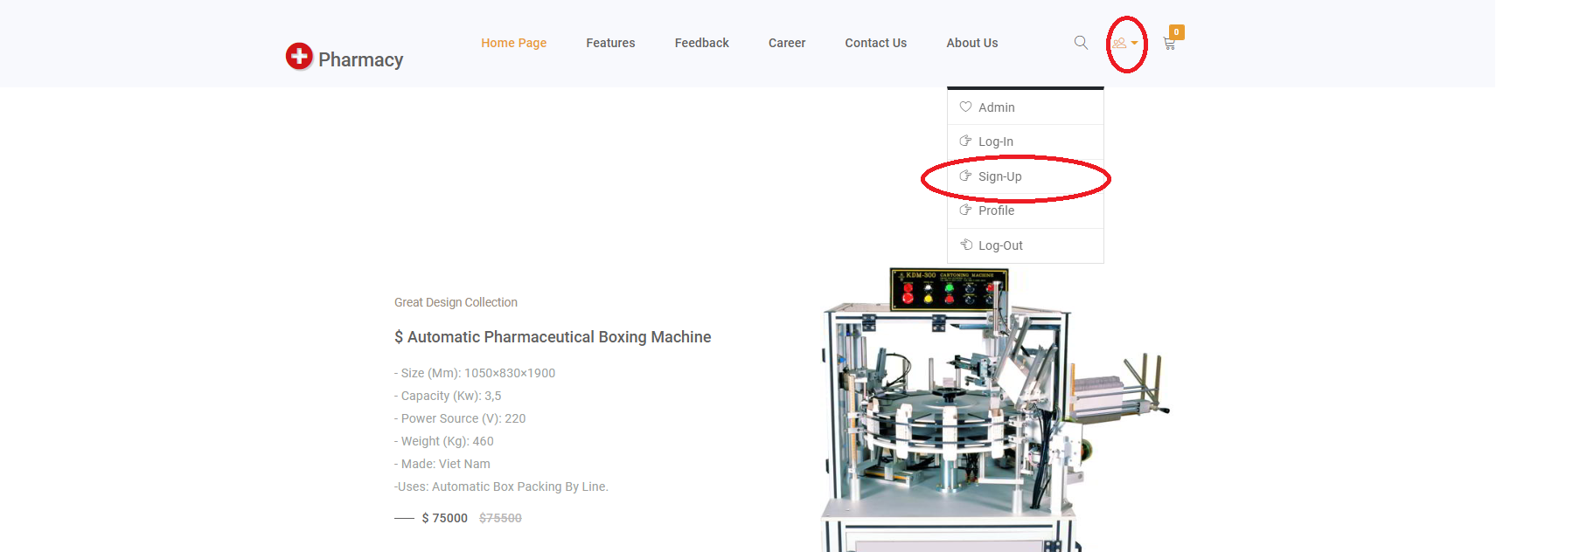

|  |  |
| --- | --- |
| **Operation No.** | **Description** |
| 1 | Click on this item on the header menu will direct customers to the Registration page |

**Register New Account:**

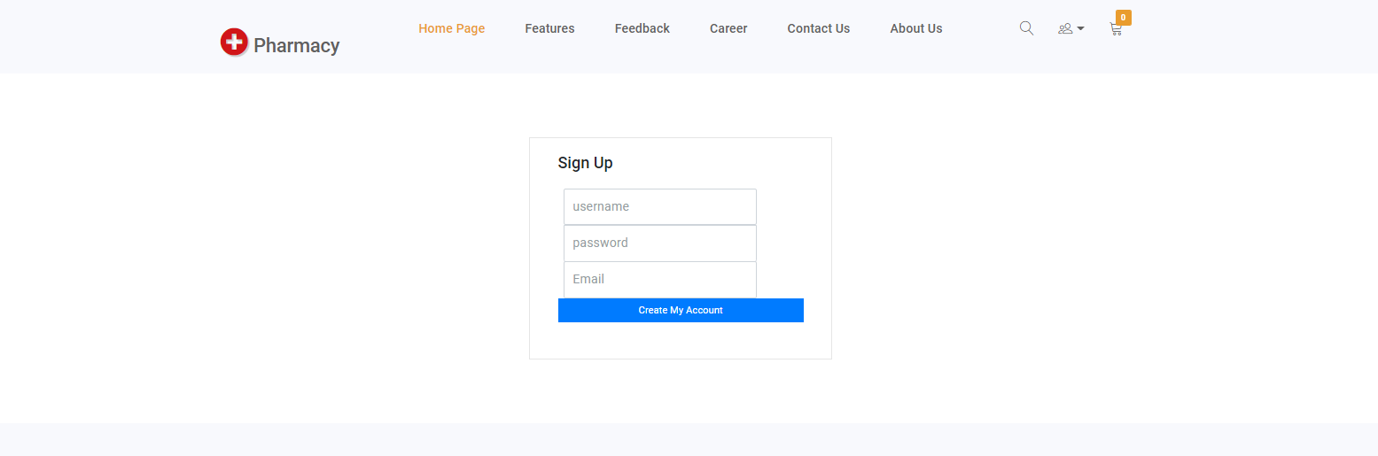

To finish registering new account, user needs to input all mandatory fields on the form:

|  |  |
| --- | --- |
| **Fields** | **Description** |
| Username | * This field is mandatory. * This field will be used as login credential along with customer’s password. * Username must be unique in the system. * Username will be display throughout the website. |
| Password | * This field is mandatory. * This field will be used as login credential along with customer’s username. * Password can contain alphabet, digit character and special character. |
| Email | * This field is mandatory. * Allow user to input his/ her email. Email format must be correct. |

* + When user submits to register new account and all the information are correct, user’s account will be created in the system with role as “USER” and the user will be directed to check code page.
* Check code :
* 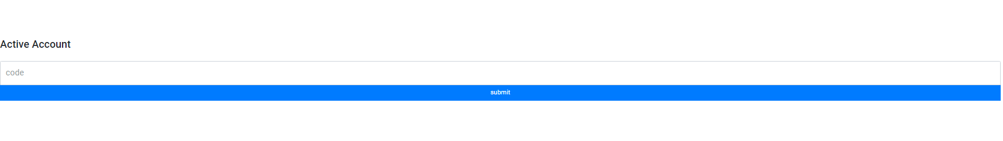
* When user submits to register new account ,an email will send to your mail box, check it and fill in excactly to finish

1. ***Login:***
2. **Description:**

* Users can sign in into the website to have permission on update profile.

**Design and Operation:**

**How to get to login page:** When users haven’t yet signed in, then on the header menu of the website, there will be the “Login” option for user to sign in into their account on the website.

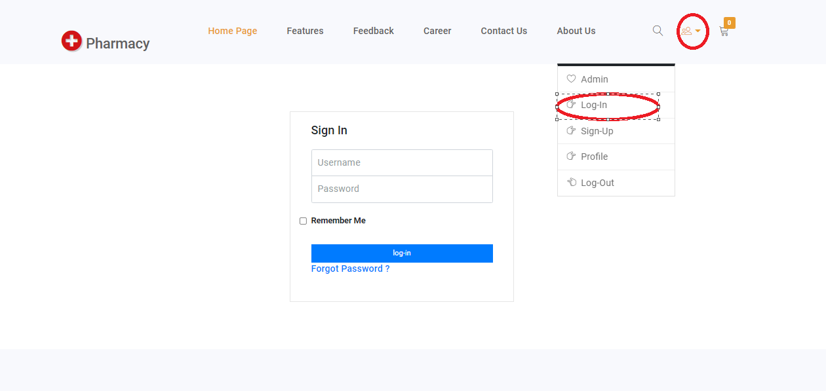

|  |  |
| --- | --- |
| **Operation No.** | **Description** |
| 1 | Click on this item on the header menu will direct customers to the Login page |

* **Login into website:**
  + To login into the website, user needs to input the login credentials on the login form:

|  |  |
| --- | --- |
| **Fields** | **Description** |
| Username | * This field is mandatory. * This field will be checked if it exists as well as it is mapped with the inputted password or not. |
| Password | * This field is mandatory. * This field will be checked if it is mapped with the inputted username or not. |

1. ***Logout:***
2. **Description:**

Customer can log out of the website whenever he/she doesn’t want to use his/her account .

**b .Design and Operation:**

**How to get log out:** When users have already signed in, then on the header menu of the website, right of user’s name will display a icon log out. Clicking on the icon will log out his/ her account from the website.

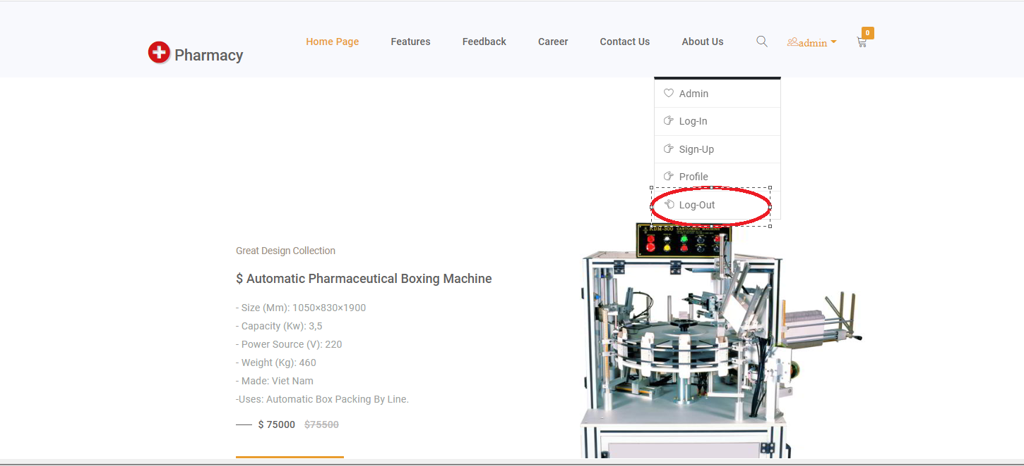

|  |  |
| --- | --- |
| **Operation No.** | **Description** |
| 1 | Click on this option will log out the customer’s account from the website and direct customers to the Homepage |

1. ***Features:***
2. **Description:**

* User can view the product which are currently on display. Customer can:
  + View the detail of Products.
  + Buy product

**Design and Operation:**

**How to get to view the post:** User can view the list of posts whenever he/she has already logged in or not.

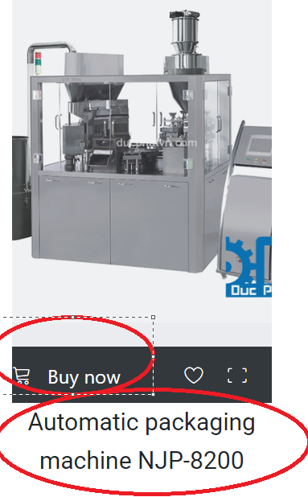

|  |  |
| --- | --- |
| **Operation No.** | **Description** |
| 1 | Click on product’name will direct customers to read details of that product |
| 2 | Click on “Buy Now” button will let customers to access to fill client form to buy product |

1. **Client Form:**

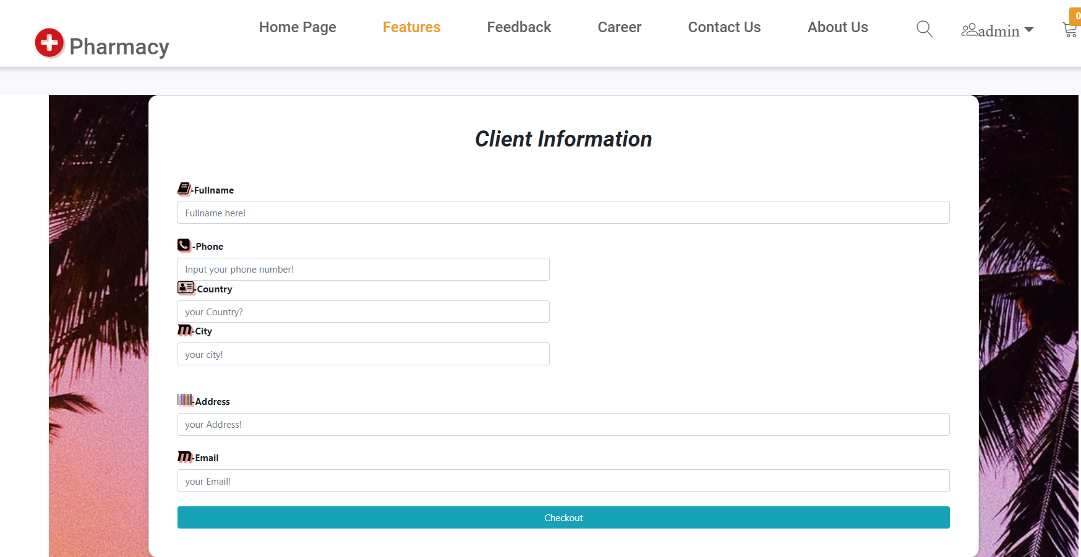

|  |  |
| --- | --- |
| **Fields** | **Description** |
| -Fullname  -Phone  -Country  -City  -Address  -Email | * These fields are mandatory. |

1. ***Feedback:***

**Description:**

* User can view the product which are currently on display. Customer can:
  + View the detail of Products.
  + Buy product

**Design and Operation:**

**How to get to view Feedback:** User can click on “Feedback” on header menu to access to Feedback Form.

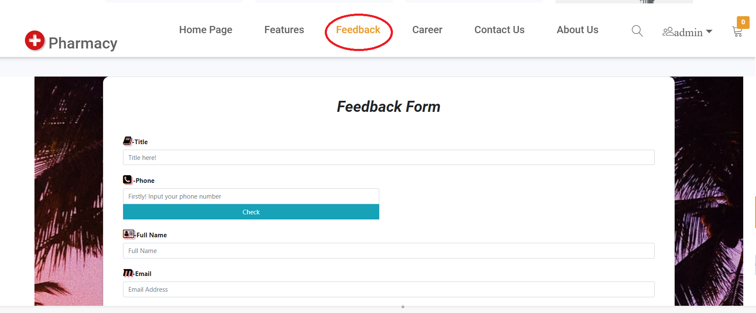

|  |  |
| --- | --- |
| **Operation No.** | **Description** |
| 1 | Click on “Feedback” will direct customers to Fill a feedback form |

**Description :**

Firstly , you have to fill phone number that used to buy product to feedback about that product.

Example : 0938242721

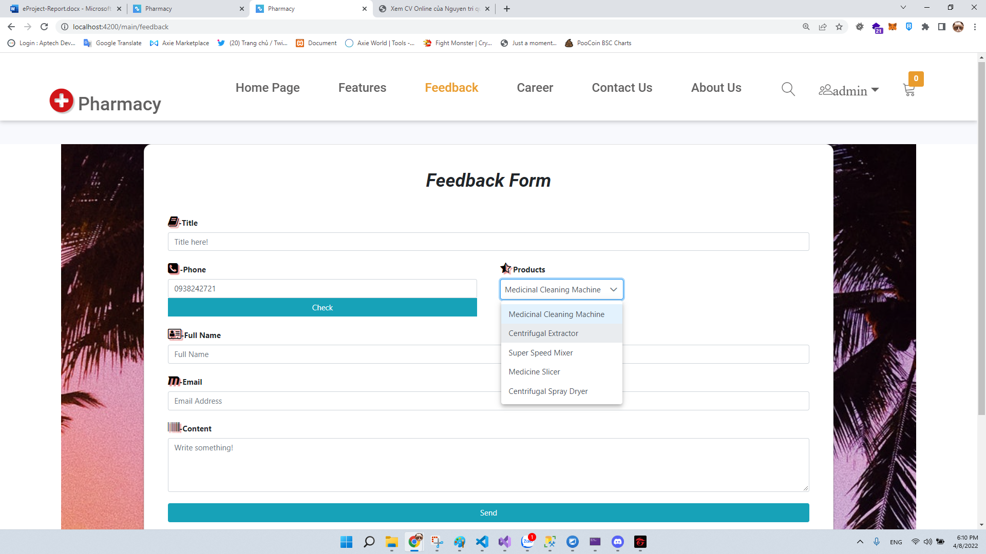

|  |  |
| --- | --- |
| **Fields** | **Description** |
| -Title  -Phone  -Country  -City  -Address  -Email | * These fields are mandatory. |

1. ***Career:***

**Description:**

* User can view the list of Career which are currently on display. Customer can:
  + View the detail of Career.
  + Apply for a job if their Profiles were updated

**Design and Operation:**

**How to get to view Career:** User can click on “Career” on header menu to access to Feedback Form.

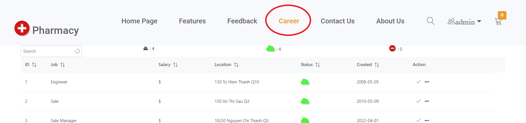

|  |  |
| --- | --- |
| **Operation No.** | **Description** |
| 1 | Click on “Career” will direct customers to read details of that product |
| 2 | Click on “V” button will let clients to apply for jobs |

**Description :**

Firstly , clients have to update their profile to apply for jobs

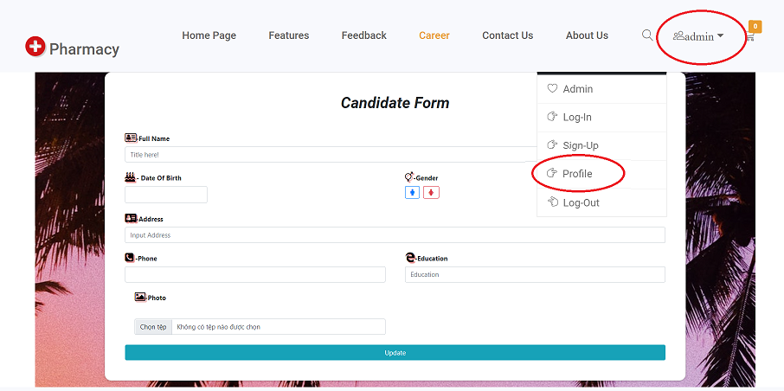

|  |  |
| --- | --- |
| **Fields** | **Description** |
| -Fullname  -Phone  -Date of Birth  -Gender  -Education  -Photo | * These fields are mandatory. |

Then, clients can click button “V” on the job to apply

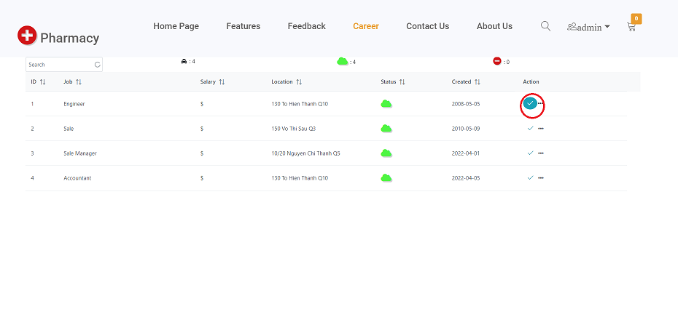

CHAPTER VI: ADMIN GUIDE

**Note:** In the system, there will be one administrator who is already configured in the system. This user has full rights on all features within the system as well as manage all other users .

1. ***Get to Administrator View***

**Description:**

* If user has role as administrator he/ she can get to the administration page to manage the master data which are used throughout the system.

**Design and Operation:**

* **How to get to Administration Site:** Only user with role as administrator and has already logged in can get to the administration site. On the header menu of the Home page, there will be the “Admin” button. Clicking on this option will direct user to the administration site.

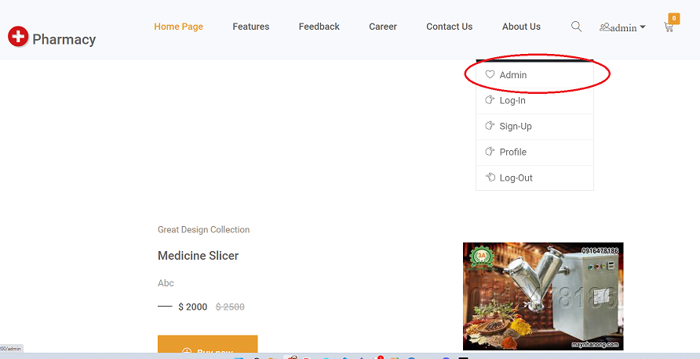

|  |  |
| --- | --- |
| **Operation No.** | **Description** |
| 1 | Click on icon admin will direct to administrator site. |

1. ***Dashboard***

**Description:**

Dashboard is navigate menu that show-off all of function management

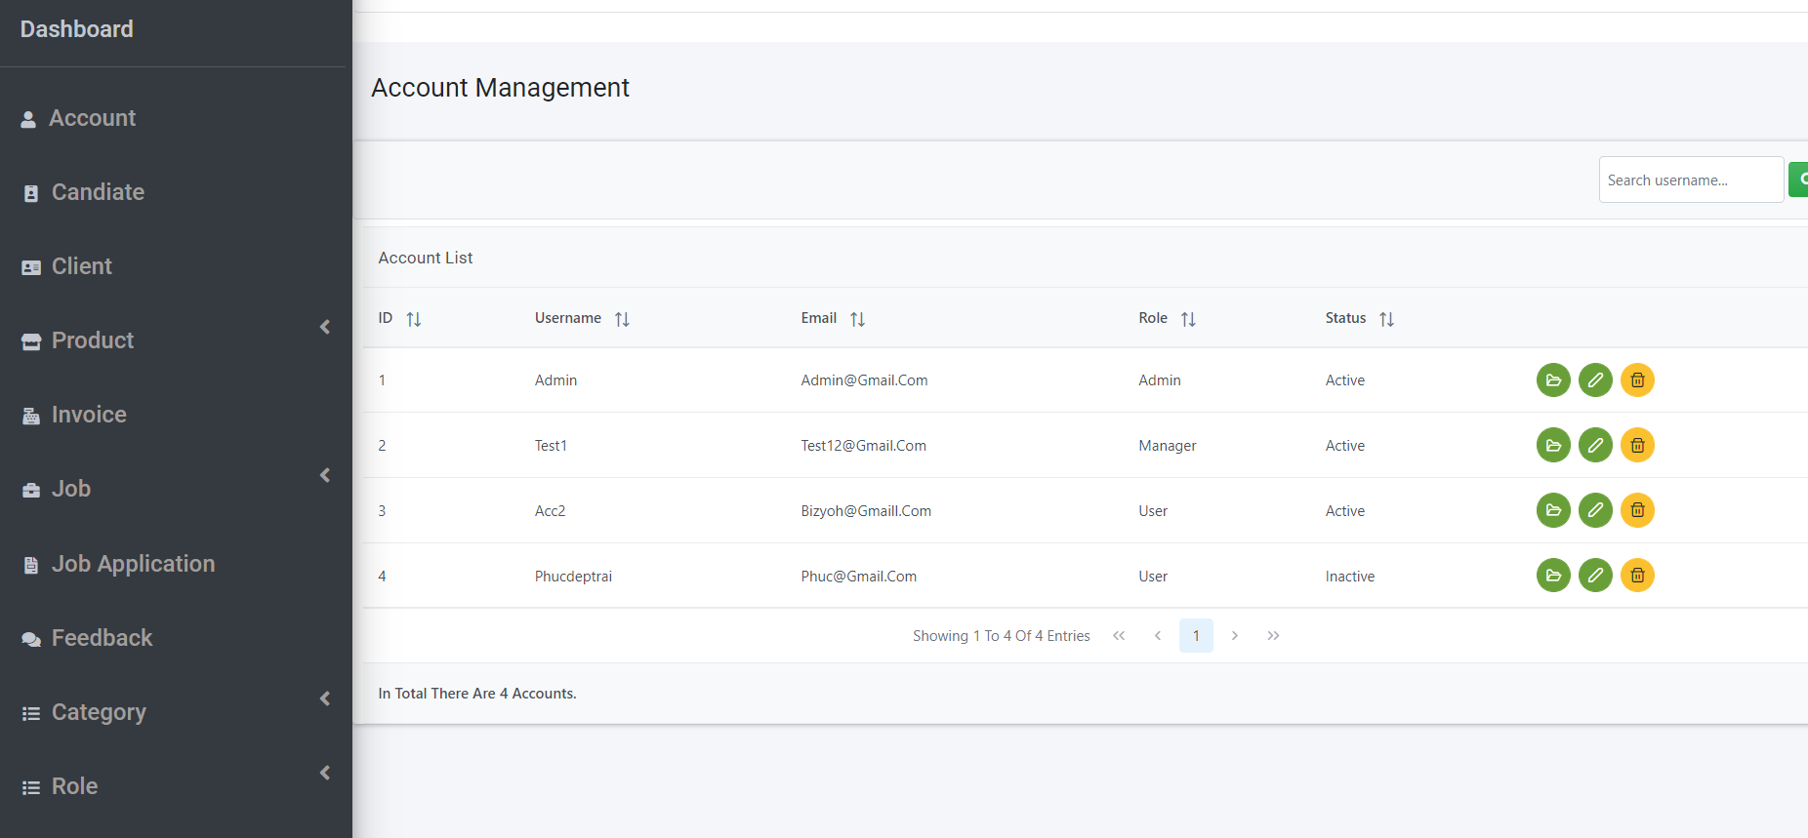

1. ***Get to Manage Account***
2. **Description: Manage Account let administrator :**

-View all of account list

-Edit account.

-Delete account.

-View Detail account.

|  |  |
| --- | --- |
| **Operation No.** | **Description** |
| 1 | Click on this option will direct user to manage account site |

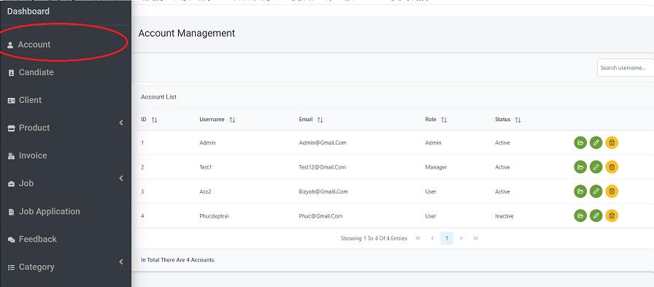

**Edit post: Edit** user can update the information of user clicking on “Edit” icon .

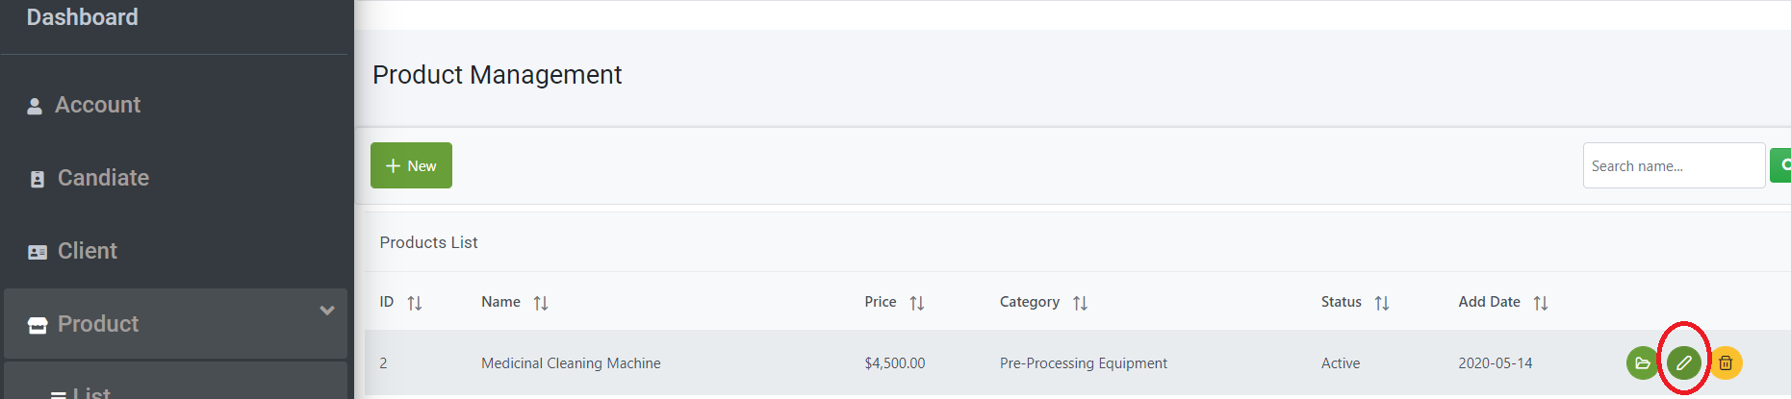

* + To finish creating new administrator, user needs to input all mandatory fields on the form:

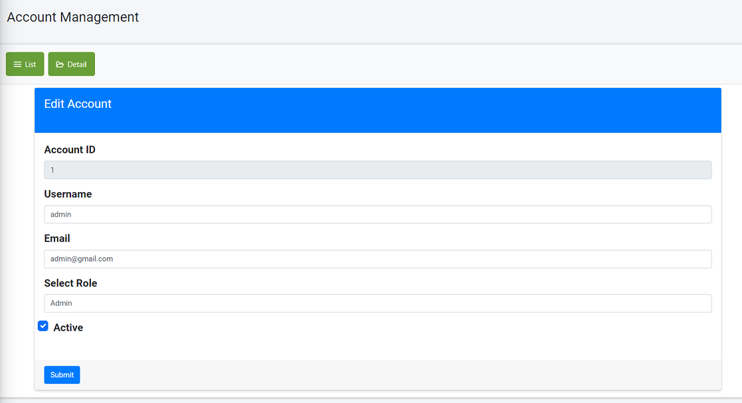

|  |  |
| --- | --- |
| **Fields** | **Description** |
| Username | * This field is mandatory. * Title will be display throughout the website. |
| Email | * This field is mandatory. * This will display the content of post |
| Role | * This field is mandatory. * Image will be display throughout the website |
| Status | * This field is mandatory. * This is select category of post |

* **Delete post:** user can delete the post by clicking on “Delete” icon on the list page.

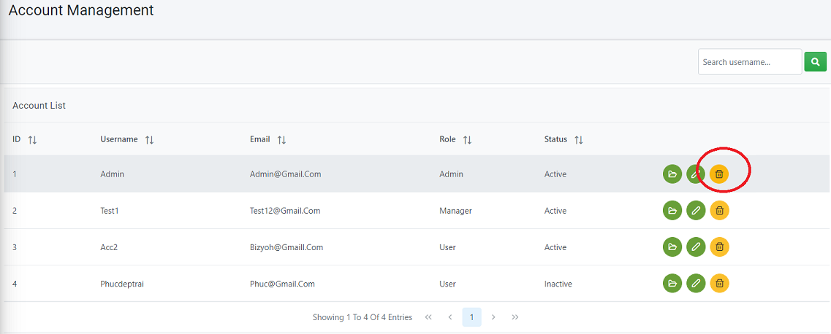

* + To finish Delete qccount administrator need to confirm one time.

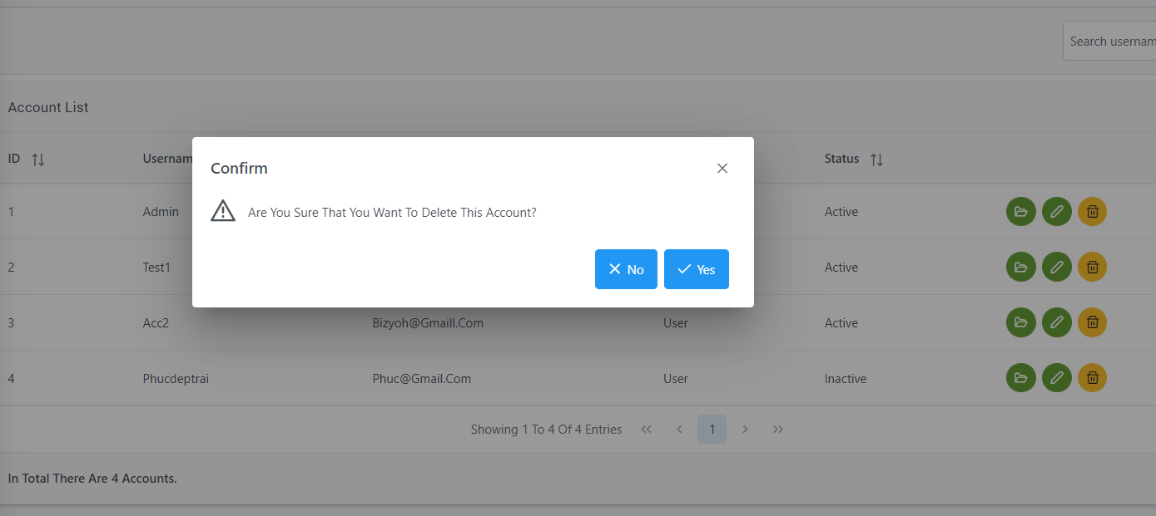

|  |  |
| --- | --- |
| **Operation No.** | **Description** |
| 1 | Click on this option will let adminitrator to Delete the account. |

* **Search:** Adminitrator can search the post

|  |  |
| --- | --- |
| **Operation No.** | **Description** |
| 1 | Click on search box will direct adminitrator to type search username |
| 2 | Click on “search” button will show all the search result |

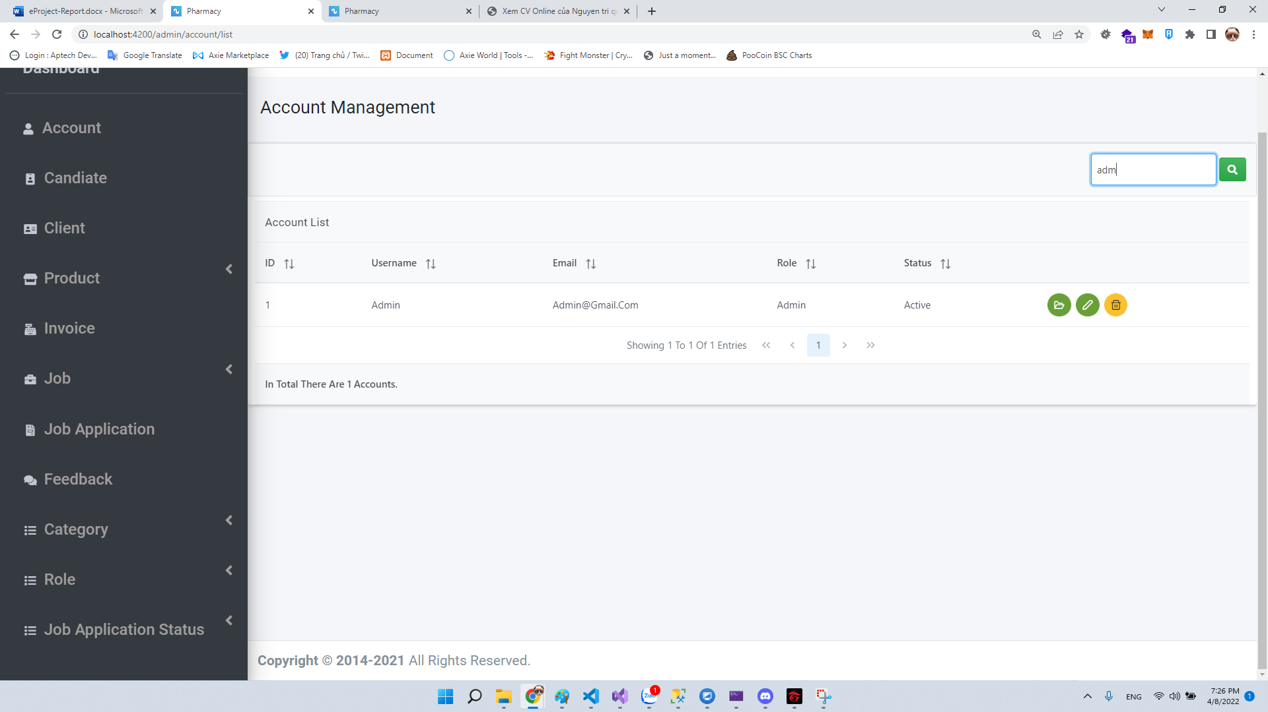

.

1. ***Get to Candidate***

**Description: Candidate manage let administrator :**

-View all of Candidate informations.

-View detail of Candidate form.

-Edit Candidate.

-Delete Candidate.

|  |  |
| --- | --- |
| **Operation No.** | **Description** |
| 1 | Click on this option will direct user to category mange site |

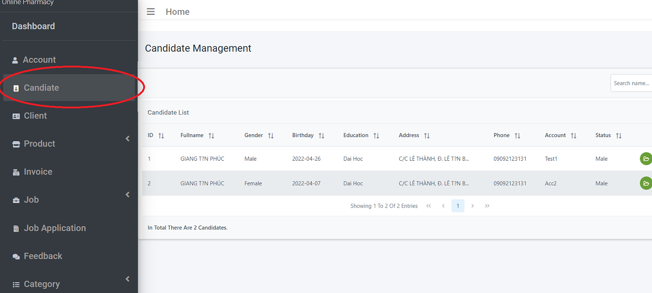

**Edit post: Edit** user can update the information of user clicking on “Edit” icon .

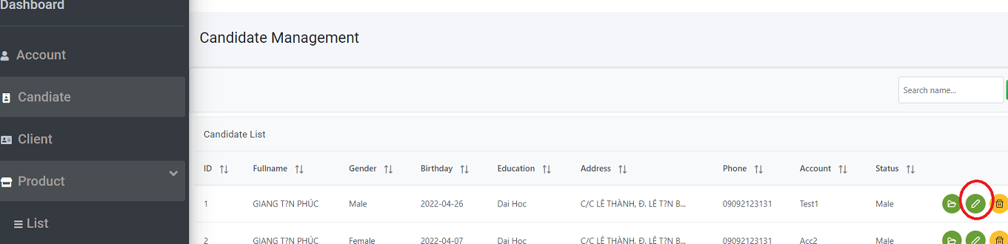

* + To finish creating new administrator, user needs to input all mandatory fields on the form:

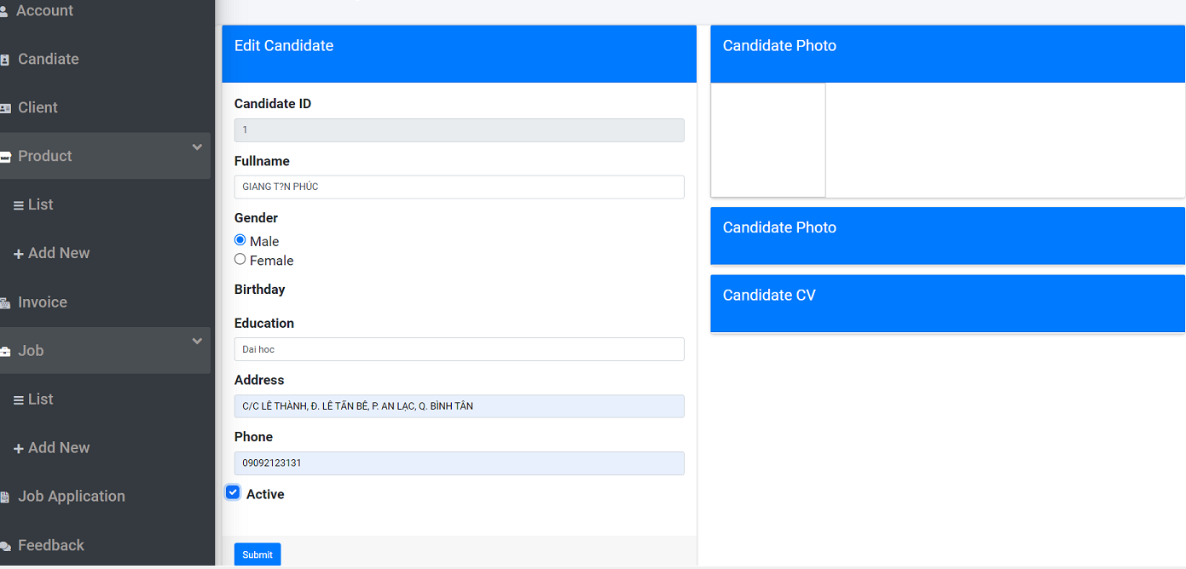

|  |  |
| --- | --- |
| **Fields** | **Description** |
| Fullname | * This field is mandatory. |
| Gender | * This field is mandatory. |
| Education | * This field is mandatory. |
| Phone | * This field is mandatory. |
| Address | * This field is mandatory. |

* **Delete :** Admin can delete the Candidate by clicking on “Delete” icon on the list page.

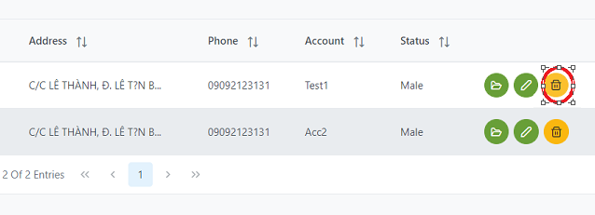

* + To finish Delete Candidate administrator need to confirm one time.

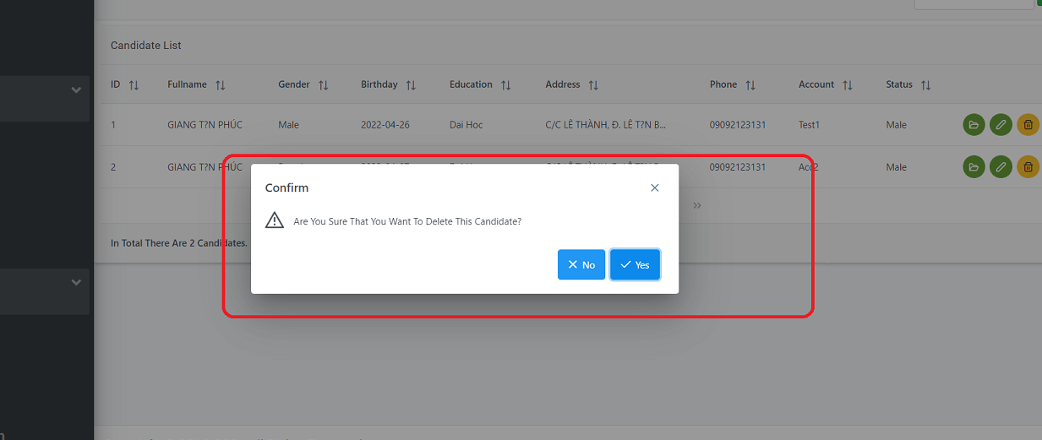

|  |  |
| --- | --- |
| **Operation No.** | **Description** |
| 1 | Click on this option will let adminitrator to Delete the Candidate. |

* **Search:** Adminitrator can search the Candidate’name

|  |  |
| --- | --- |
| **Operation No.** | **Description** |
| 1 | Click on search box will direct adminitrator to type search fullname |
| 2 | Click on “search” button will show all the search result |

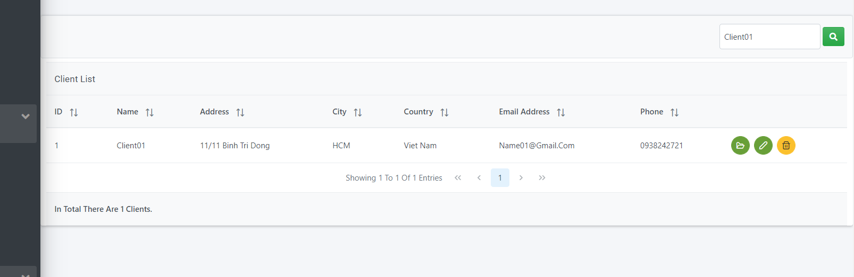

1. ***Get to Client***

**Description: Client manage let administrator :**

-View all of Client informations.

-View detail of Client.

-Edit Client information.

-Delete Client.

|  |  |
| --- | --- |
| **Operation No.** | **Description** |
| 1 | Click on this option will direct user to Client manage site |

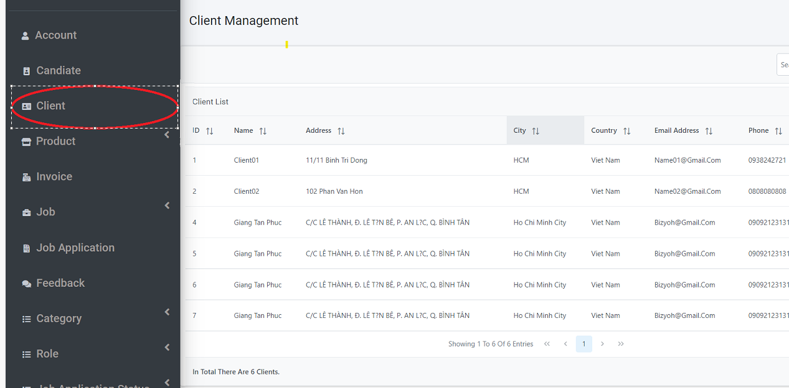

* **Edit Client:** admin can update the information of post by clicking on “Edit” icon on the list page.

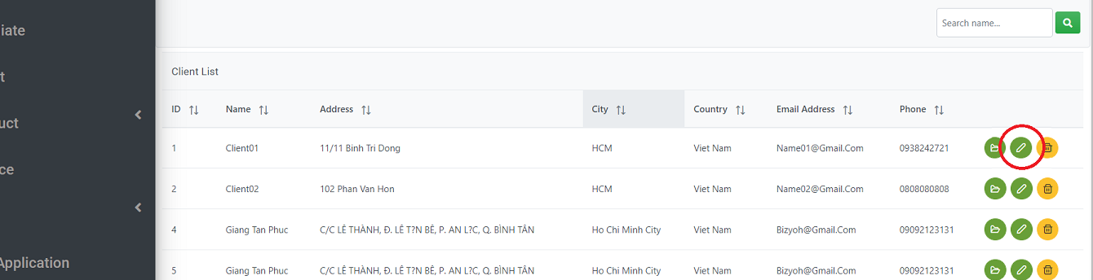

* **Delete :** Admin can delete the Client by clicking on “Delete” icon on the list page.

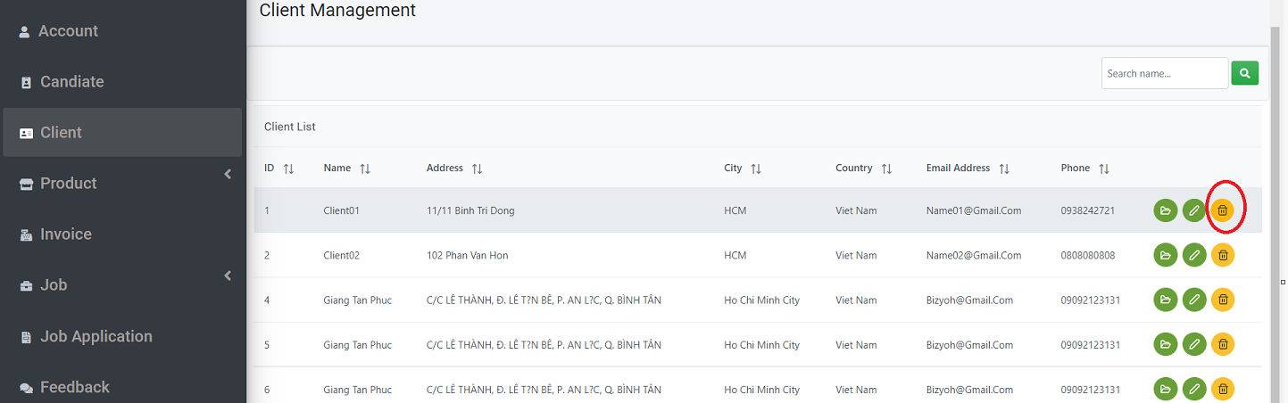

* + To finish Delete Client administrator need to confirm one time.



|  |  |
| --- | --- |
| **Operation No.** | **Description** |
| 1 | Click on this option will let adminitrator to Delete the Candidate. |

1. ***Get to Product manage***

**Description: Products manage let administrator :**

-View all of Products.

-Search Products.

-Delete Products.

-Add a new Product

* **Add a New Product:** user can create new post by clicking on “New Product” button on the list page.

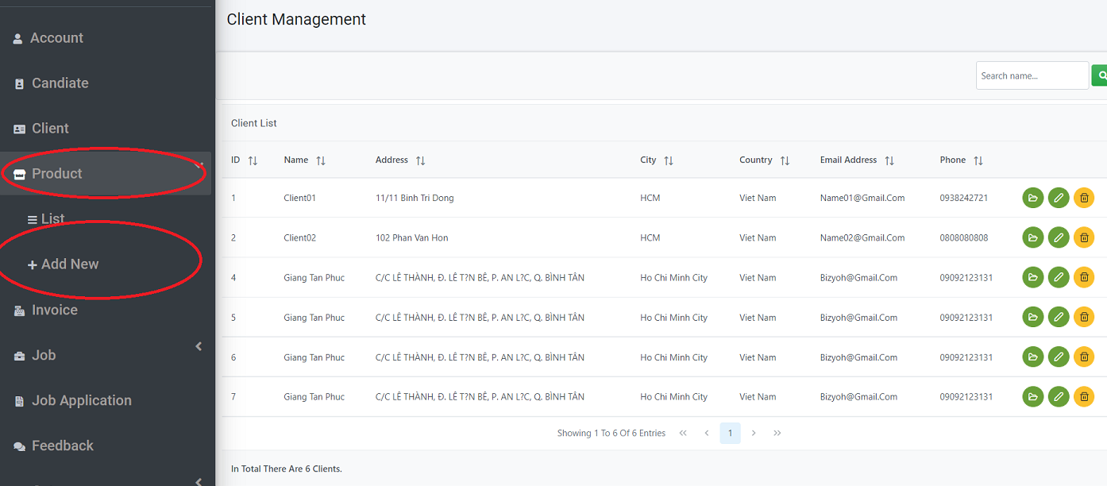

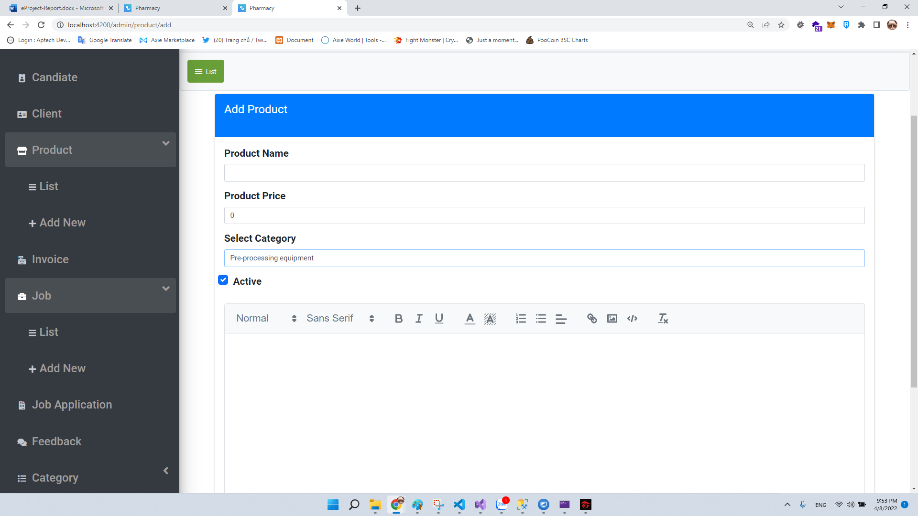

|  |  |
| --- | --- |
| **Fields** | **Description** |
| Product Name | * This field is mandatory. |
| Price | * This field is mandatory. |
| Category | * This field is mandatory. |
| Status | * This field is mandatory. |
| Description | * This field is mandatory. |

**Edit Product:** admin can update the information of post by clicking on “Edit” icon on the list page.

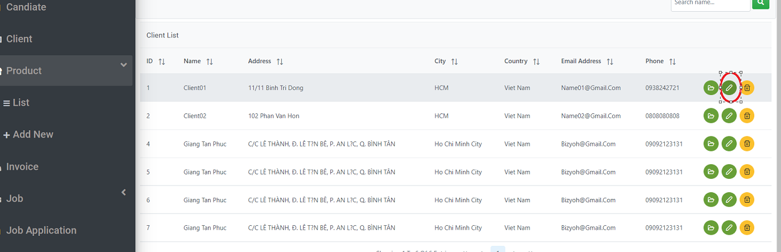

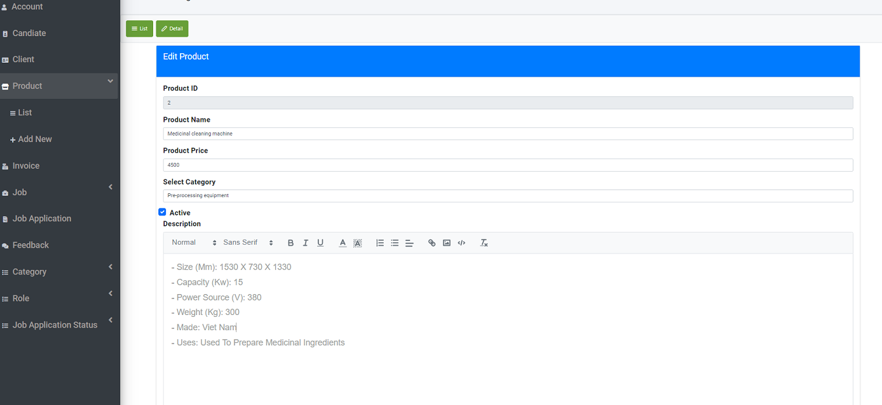

|  |  |
| --- | --- |
| **Fields** | **Description** |
| Product Name | * This field is mandatory. |
| Price | * This field is mandatory. |
| Category | * This field is mandatory. |
| Status | * This field is mandatory. |
| Description | * This field is mandatory. |

* **Delete:** Admin can Delete the information of Product by clicking on “Delete” icon on the list page.

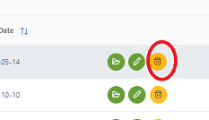

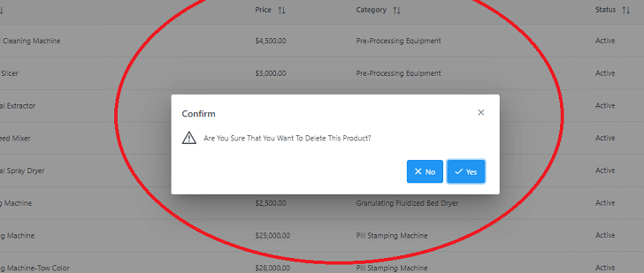

|  |  |
| --- | --- |
| **Operation No.** | **Description** |
| 1 | Click on this option will let adminitrator to Delete the Product. |

1. ***Get to Job manage***

**Description: Job management let administrator :**

-View all of Jobs.

-Search Job.

-Delete Job.

-Add a new Job

* **Add a New Job:** user can create new post by clicking on “Add New” button on the list page.

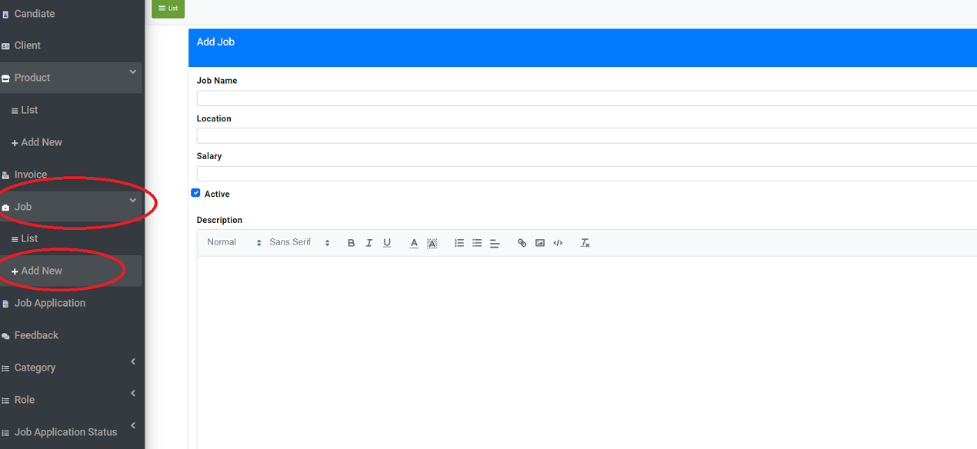

|  |  |
| --- | --- |
| **Fields** | **Description** |
| Job Name | * This field is mandatory. |
| Location | * This field is mandatory. |
| Status | * This field is mandatory. |
| Description | * This field is mandatory. |

**Edit Job:** admin can update the information of post by clicking on “Edit” icon on the list page.

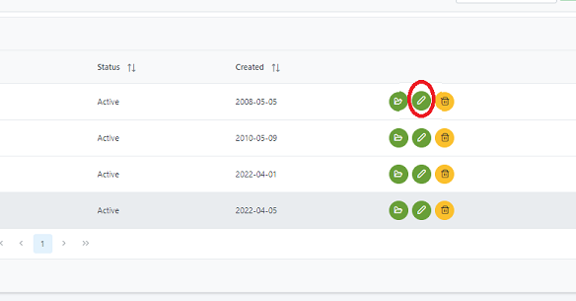

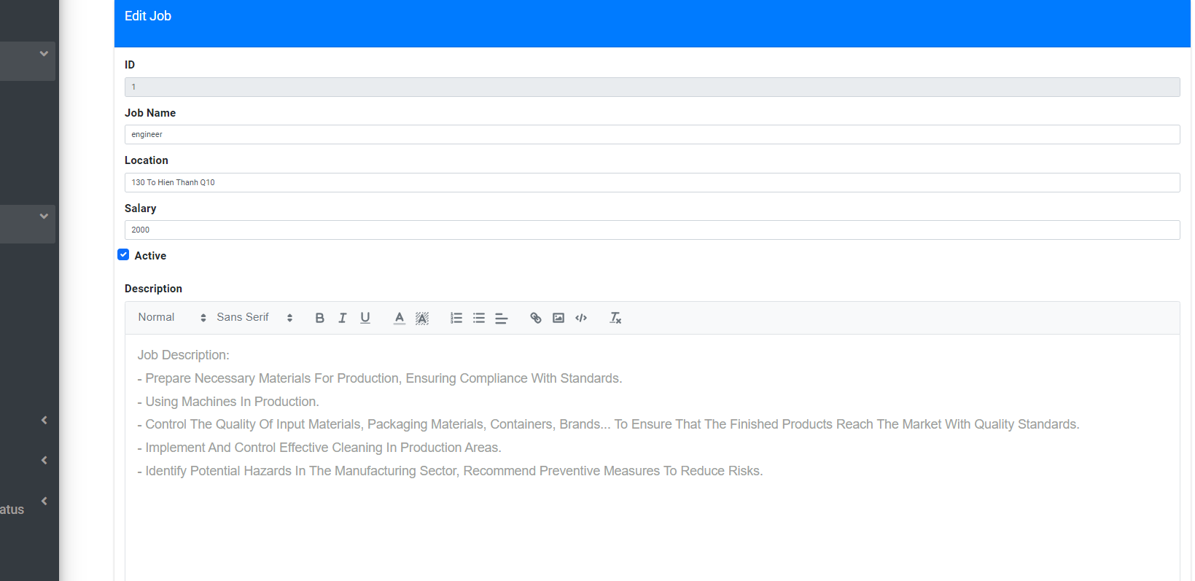

|  |  |
| --- | --- |
| **Fields** | **Description** |
| Job Name | * This field is mandatory. |
| Location | * This field is mandatory. |
| Status | * This field is mandatory. |
| Description | * This field is mandatory. |

* **Delete:** Admin can Delete the information of Job by clicking on “Delete” icon on the list page.



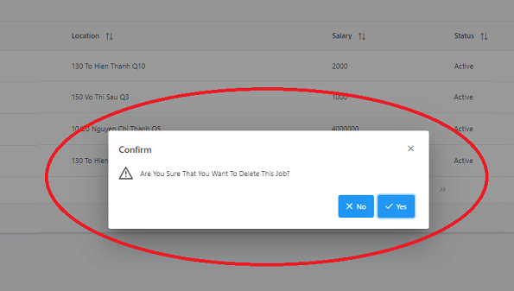

|  |  |
| --- | --- |
| **Operation No.** | **Description** |
| 1 | Click on this option will let adminitrator to Delete the Job. |

1. ***Get to Feedback management***

**Description: Job management let administrator :**

-View all of Feedbacks.

-Search Feedbacks.

-Delete Feedbacks.

-Edit Feedbacks.

-View detail Feedbacks.

|  |  |
| --- | --- |
| **Operation No.** | **Description** |
| 1 | Click on this option will direct user to Feedback manage site |

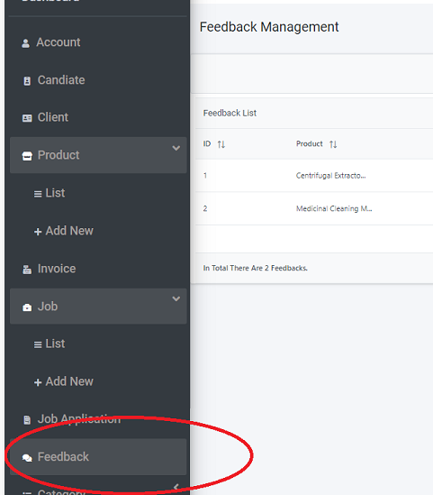

**Edit** Feedbacks**:** admin can update the information of post by clicking on “Edit” icon on the list page.

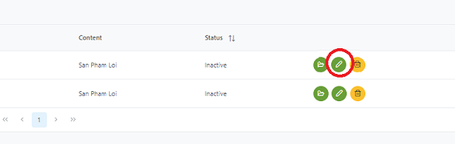

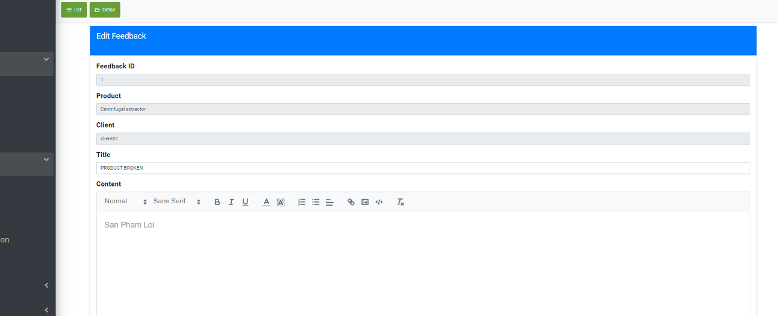

|  |  |
| --- | --- |
| **Fields** | **Description** |
| Feedback ID | * This field is automatic filled. * Cannot edit |
| Product | * This field is automatic filled. * Cannot edit |
| Title | * This field is mandatory. |
| Content | * This field is mandatory. |

* **Delete:** Admin can Delete the information of Feedbacks by clicking on “Delete” icon on the list page.

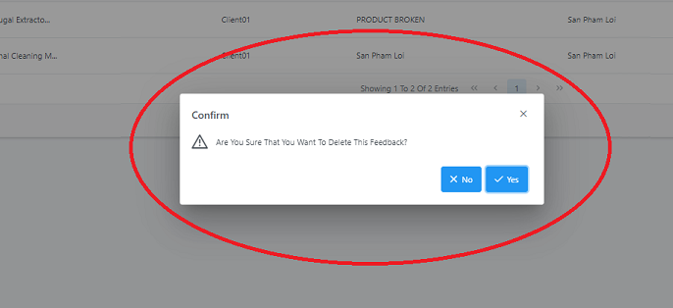

|  |  |
| --- | --- |
| **Operation No.** | **Description** |
| 1 | Click on this option will let adminitrator to Delete the Job. |

1. ***Get to Invoice management***

**Description: Invoice management let administrator :**

-View all of Invoices.

-View detail Invoices.

|  |  |
| --- | --- |
| **Operation No.** | **Description** |
| 1 | Click on this option will direct user to Invoices manage site |

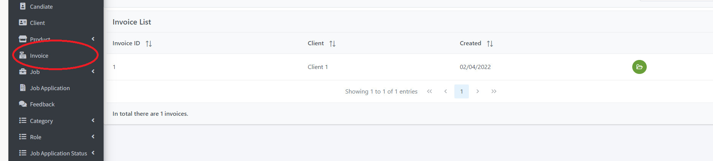

* **Detail:** Admin can view Detail the information of Invoice by clicking on “Detail” icon on the list page.

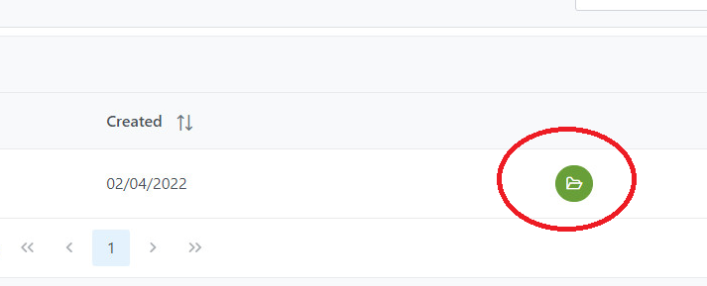

|  |  |
| --- | --- |
| **Operation No.** | **Description** |
| 1 | Click on this option will let adminitrator to View detail the Invoice. |

1. ***Get to Job Application management***

**Description: Job management let administrator :**

-View all of Job Application.

-View list of Candidates apply for jobs

|  |  |
| --- | --- |
| **Operation No.** | **Description** |
| 1 | Click on this option will direct user to Feedback manage site |

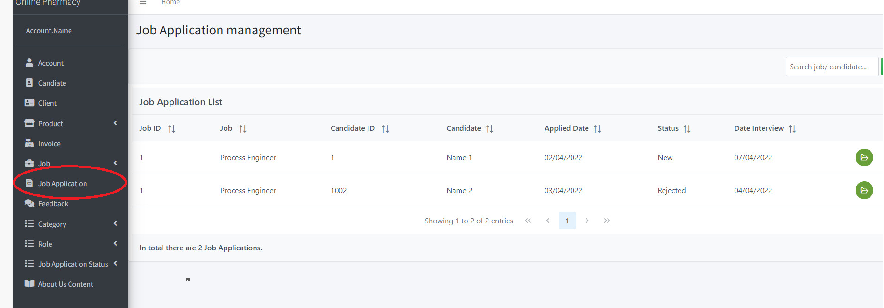

**View Detail :** admin can View the information of Job Application by clicking on “Detail” icon on the list page.

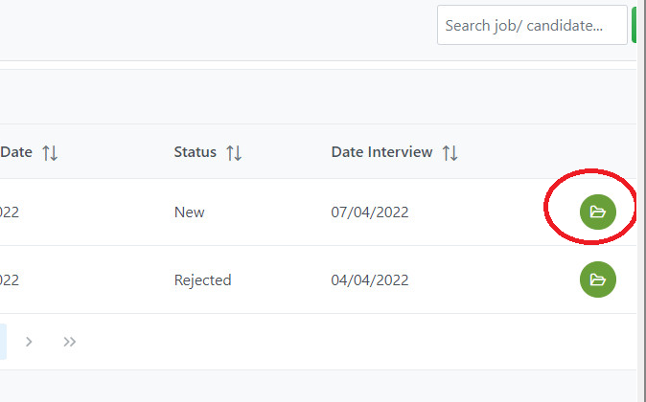**Send mail to Candidate:** admin can Approve Candidate apply for Job Application by clicking on “Send” icon on the list page.

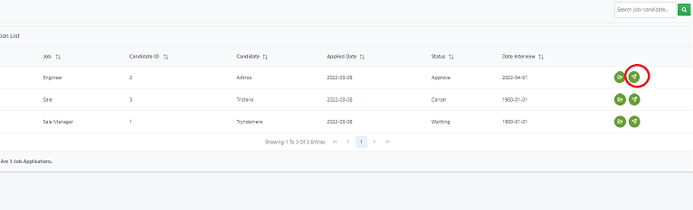

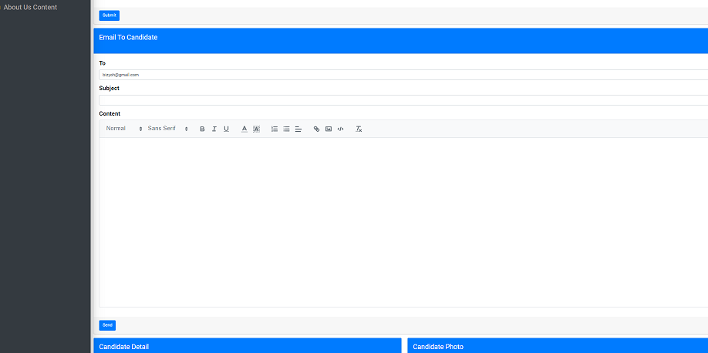

1. ***Get to Category management***

**Description: Category management let administrator :**

-View all of Category.

-Search Category.

-Delete Category.

-Add a new Category

* **Add a New Category:** user can create new post by clicking on “Add New” button on the list page.

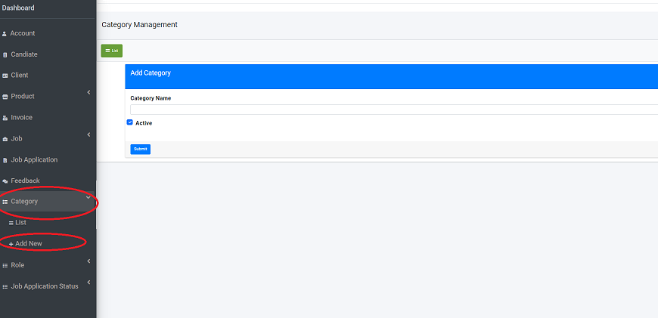

|  |  |
| --- | --- |
| **Fields** | **Description** |
| Category Name | * This field is mandatory. |

**Edit Category:** admin can update the information of Category by clicking on “Edit” icon on the list page.

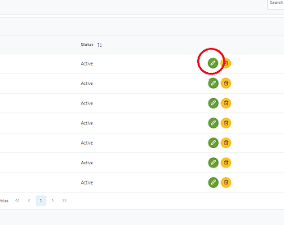

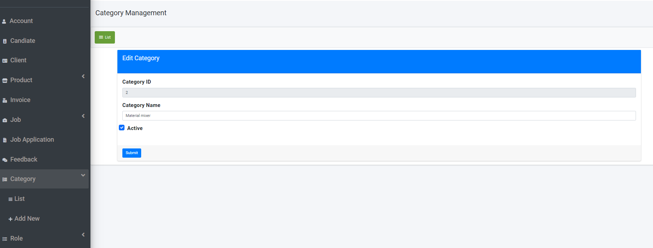

|  |  |
| --- | --- |
| **Fields** | **Description** |
| Id | * This field is automatic filled. |
| Category Name | * This field is mandatory. |

* **Delete:** Admin can Delete the information of Category by clicking on “Delete” icon on the list page.



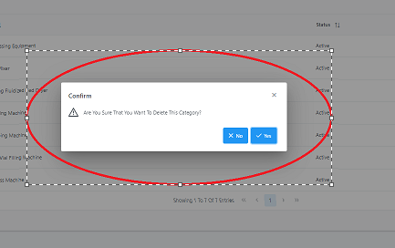

|  |  |
| --- | --- |
| **Operation No.** | **Description** |
| 1 | Click on this option will let adminitrator to Delete the Category. |

1. ***Get to Role management***

**Description: Role management let administrator :**

-View all of Roles.

-Search Roles.

-Delete Role.

-Add a new Role

* **Add a New Role:** user can create new post by clicking on “Add New” button on the list page.

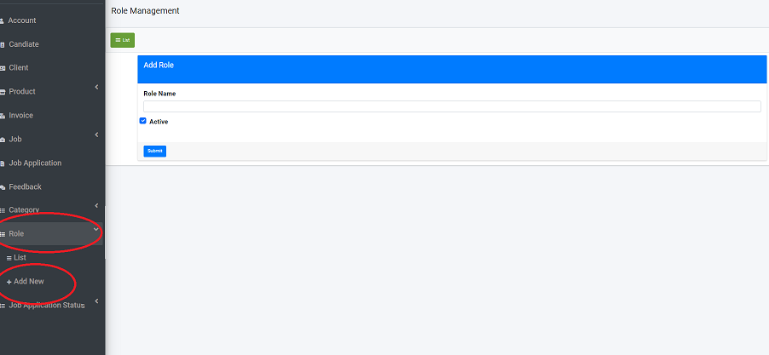

|  |  |
| --- | --- |
| **Fields** | **Description** |
| Role Name | * This field is mandatory. |

**Edit Role:** admin can update the information of Category by clicking on “Edit” icon on the list page.





|  |  |
| --- | --- |
| **Fields** | **Description** |
| Id | * This field is automatic filled. |
| Category Name | * This field is mandatory. |

* **Delete:** Admin can Delete the information of Category by clicking on “Delete” icon on the list page.





|  |  |
| --- | --- |
| **Operation No.** | **Description** |
| 1 | Click on this option will let adminitrator to Delete the Role. |

1. ***Get to Job Application Status management***

**Description: Job Application Status management let administrator :**

-View all of Application Status .

-Search Status.

-Delete Status.

-Add a new Status.

* **Add a New Job Application Status:** user can create new post by clicking on “Add New” button on the list page.

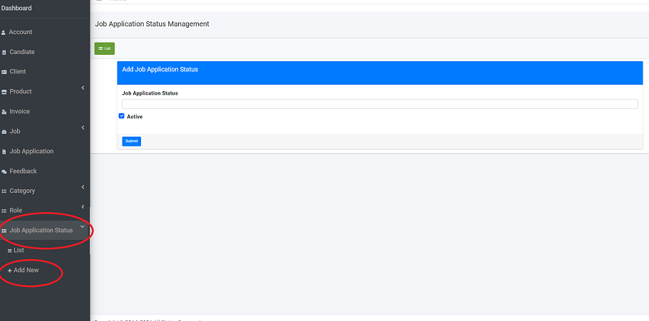

|  |  |
| --- | --- |
| **Fields** | **Description** |
| **Job Application Status** | * This field is mandatory. |

**Edit Role:** admin can update the information of Job Application Status by clicking on “Edit” icon on the list page.

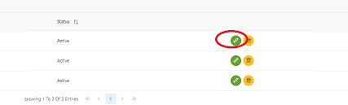

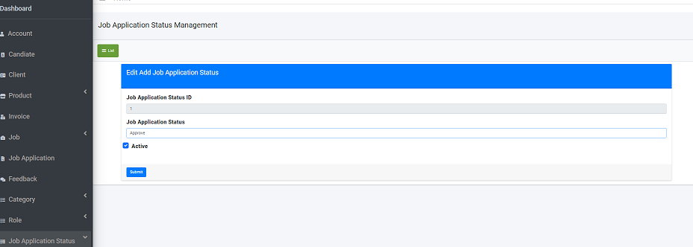

|  |  |
| --- | --- |
| **Fields** | **Description** |
| Id | * This field is automatic filled. |
| Job Application Status Name | * This field is mandatory. |

* **Delete:** Admin can Delete the information of Job Application Status by clicking on “Delete” icon on the list page.



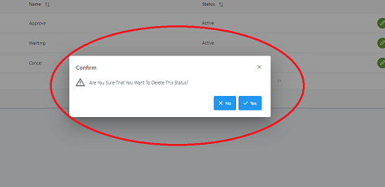

|  |  |
| --- | --- |
| **Operation No.** | **Description** |
| 1 | Click on this option will let adminitrator to Delete the Status. |

1. ***Get to About Us Page:***

|  |  |
| --- | --- |
| **Operation No.** | **Description** |
| 1 | Click on this option will direct user to Feedback manage site |

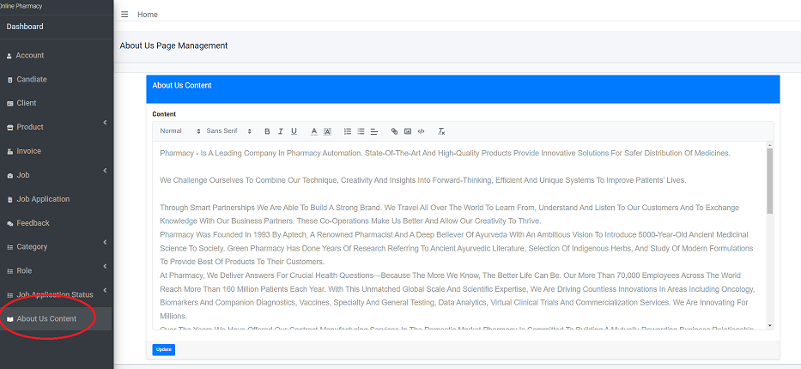

**Edit Content:** admin can update the information about About Us page .

CHAPTER VII: DEVELOPER GUIDE

* + - 1. ***Visual Studio 2022 – ASP.NET***

**Change Port:**

1. Open the Project control panel, stop all running modules.
2. Click the “Properties” -> “launchSettings.json” to change applicationUrl to "http://localhost:5235"
3. Save the project.

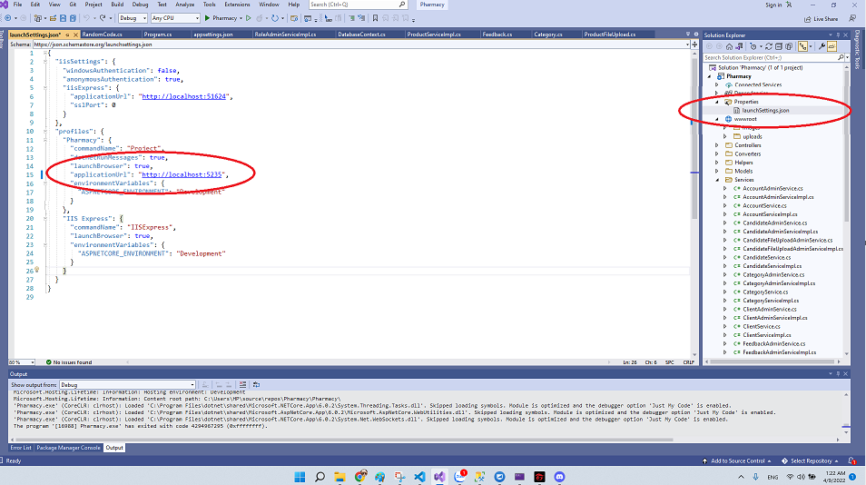

**2. Microsoft SQL Server Management Studio 18:**

* 1. Connect with Server

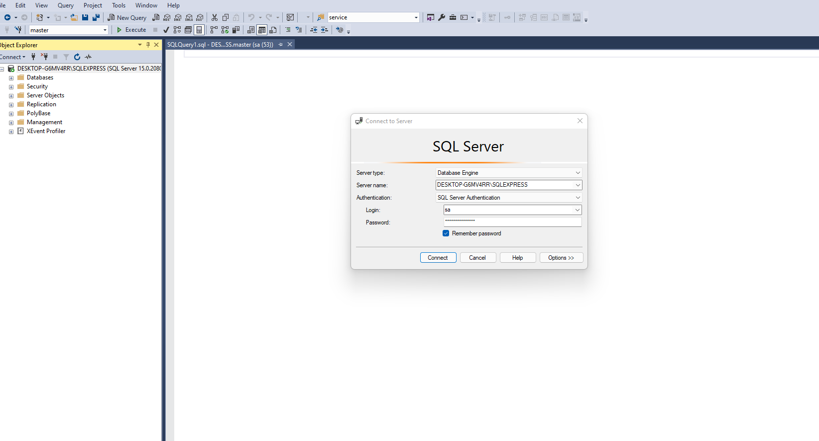

* 1. Click on “New Querry”

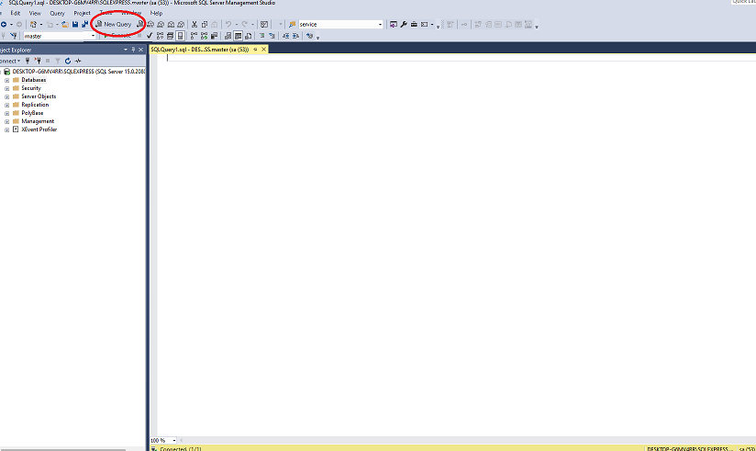

* 1. Open file “QuerryDBS.txt” and coppy all text paste into querry Sql then click on “Execute”.

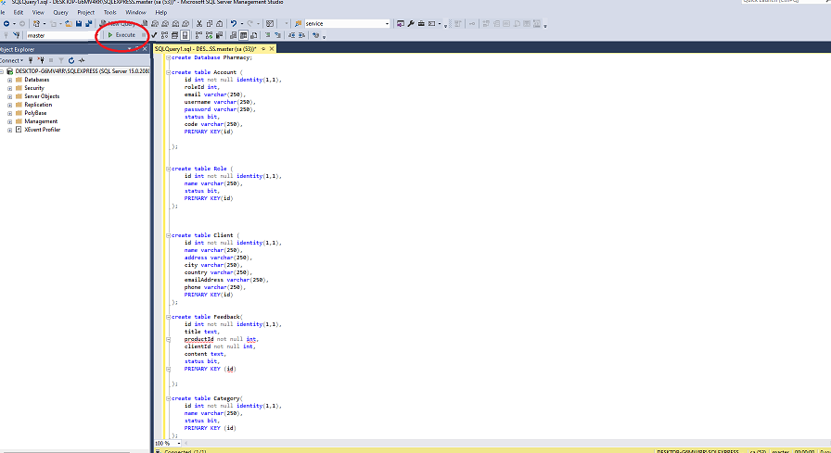

**3.Visual Code - Angular:**

A . Open Visual Code and Open Folder Pharmacy

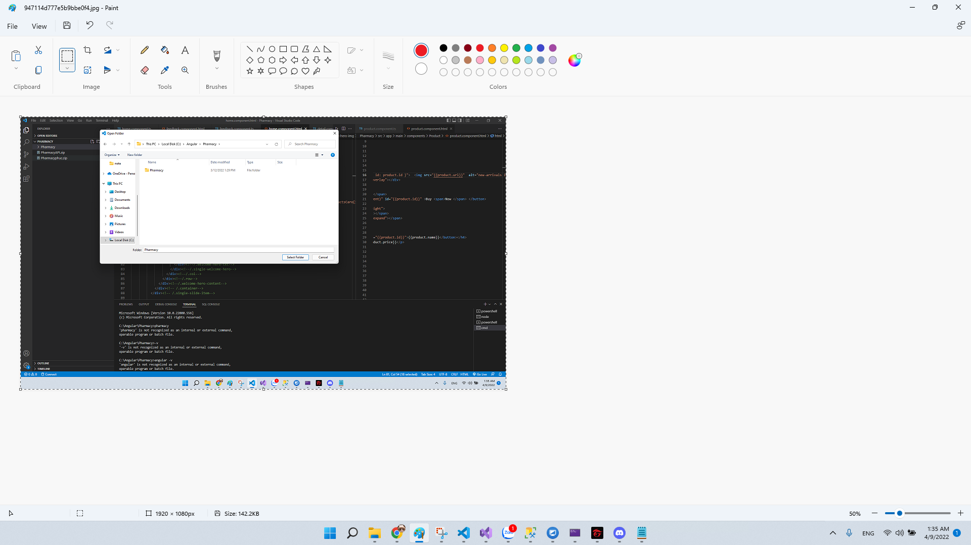

B. Click on tab Terminal by CMD and type “ng serve --open" to open project.

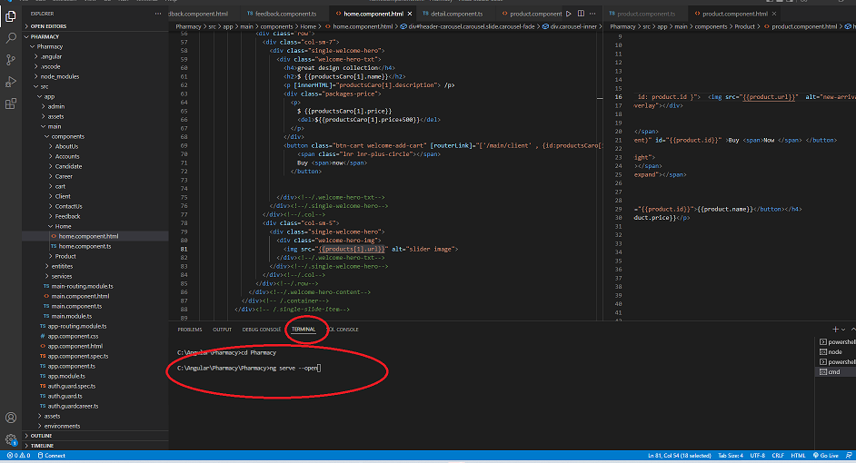

**Access the website**

